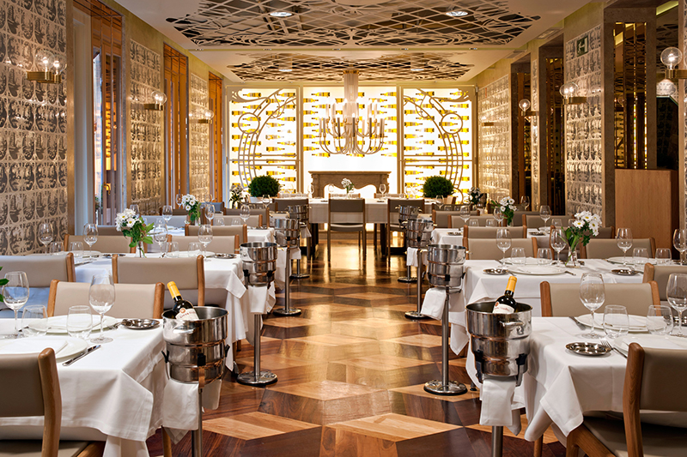

|  |
| --- |
| PROJECT REPORT:  RESTAURANT MANAGEMENT |
| DATABASE |
| JUNE 03  GROUP 4_DSEB   1. Tran Minh Khoa_11196206 2. Tran Huong Giang_11191469 3. Duong Thi Thu Phuong_11194195 4. Bui Thi Thu Huong_11192247 |

Table of Contents

I. INTRODUCTION 3

1. Problems 3

2. Project’s targets 3

II. CONTENTS 3

1. Data description 3

2. Relationship 5

3. Diagram 6

4. Job description 6

5. Select 6

*5.1 The most used table* 6

*5.2 Top 5 customers who spent the most in March* 7

*5.3 Coupons that have never been used* 7

*5.4 Most used coupons* 8

*5.5 Dishes ordered less than 10 times* 8

*5.6 Foods that sold above average* 9

*5.7 Find out which shift does not have enough staff position* 10

*5.8 Top 5 customers that tried the fewest dishes at the restaurant* 10

*5.9 The ingredient which the restaurant spend the most on*  11

*5.10 The part of the day with the most employees taking leave* 11

*5.11 The period with the most visitors* 12

6. Views 12

*6.1 Worst-selling foods.* 12

*6.2 Ingredients that are used in most foods.* 13

*6.3 Revenue of each month.* 13

*6.4 Total expense of each month.* 14

*6.5 Employees’ salary.* 14

*6.6 Profit of each month.* 15

7. Procedures 16

*7.1 Search for available coupons.* 16

*7.2 Search for employees in a specific shift.* 16

*7.3 Move bills to the backup table.* 17

*7.4 Increase the price of the best-selling dish.* 18

*7.5 Find the tables available at a specific time.* 18

8. Triggers 19

*8.1 Calculate the discount and final value of bills.* 19

*8.2 Increase the number of times a customer uses a coupon.* 20

*8.3 Increase the quantity of ingredients in the warehouse.* 20

*8.4 Change the table status.* 21

*8.5 Delete food from the menu.* 21

*8.6 Insert or update foods.* 22

*III.CONCLUSION………….………………………………………………………….2*

# I. INTRODUCTION

1. Problems

- Customers order, pay quickly and comfortably.  
 - Manage and update items, optimal and most accurate selling prices.  
 - Accurate and fast billing control.  
 - Reports and statistics on revenue by criteria such as time, table, dish,…  
 - Profit statistics and reports must be accurate and fast.

2. Project’s targets

Build a management program:  
 - Solving small and medium restaurant management operations.  
 - Full features guaranteed.  
 - Easy to use.

# II. CONTENTS

## **1. Data description**

- Food *(Food’s name , prices):* save the dishes and their prices available in the restaurant. - Supplier *(Supplier code , name, phone number, address)*: store information of suppliers.  
 - Ingredients *(Ingredient’s name, supplier code)*: store information about ingredients and their supplier.  
 - Recipe *(Recipe code, food’s name , ingredient’s name)*: recipe information.  
 - Warehouse *(Ingredient’s name, unit, quantity)*: where to store the quantity information of the ingredients.  
 - Staff *(Staff code, name, phone number, sex, address, salary, birthday)*: store information of restaurant staff  - Customer *(Customer code, name, phone number, sex, address, birthday, registration date)*: store information about customers who have been to the restaurant. - Table *(Table code, chairs, floor, window)*: information about the tables in the restaurant.  
 - Table details *(Table code, day, time)*: store information of table used by customers. - Shift *(Shift code, start day, end day, shift)*: information about shifts. - Staff shift *( ID staff shift, staff code, shift code)*: save the information the employees have worked in any shift.  
 - Reservation *( ID, table code, customer code, date, time)*: save customer information and reservation time. - Spending *(Spending code, time, staff code, ingredient’s name, unit, quantity, prices)*: store the restaurant’s spending information.  
 - Coupon *(Coupon code, discount, minimum money, start time, end time, quantity)*: store information of promotions.   
 - Coupon used *(Customer code, coupon code, quantity)*: store information about the promotions customers have used. - Bill*(Bill code, time, table code, customer code, staff code, coupon code, prices)*: store the issued bills of the restaurant.  
 - Bill details *(Bill code, food’s name, quantity)*: save the dishes and quantity in the bill.  
 - Days off *(ID Days offs, staff code, Days offs, shift)*: save information on the date the employee quits.  
 - Bill back-up *(Bill back-up code, customer code, time, total money)*: save last month’s bills.

## 

## **2. Relationship**

|  |  |  |
| --- | --- | --- |
| NAME | NAME | RELATIONSHIP |
| Recipe | Food | 1:N |
| Bill details | Food | 1:N |
| Warehouse | Ingredients | 1:1 |
| Ingredients | Supplier | 1:N |
| Ingredients | Spending | 1:N |
| Staff | Days offs | 1:N |
| Staff | Bill | 1:N |
| Staff | Staff shift | 1:N |
| Staff shift | Shift | 1:N |
| Bill | Food | N:N |
| Bill | Coupon | 1:N |
| Bill | Table | 1:N |
| Bill | Customer | 1:N |
| Bill | Bill details | 1:N |
| Coupon | Coupon used | 1:N |
| Table | Table details | 1:N |
| Customer | Bill back-up | 1:N |
| Coupon used | Customer | 1:N |
| Customer | Coupon | 1:N |
| Customer | Reservation | 1:N |
| Table | Reservation | 1:N |

## **3. Diagram**

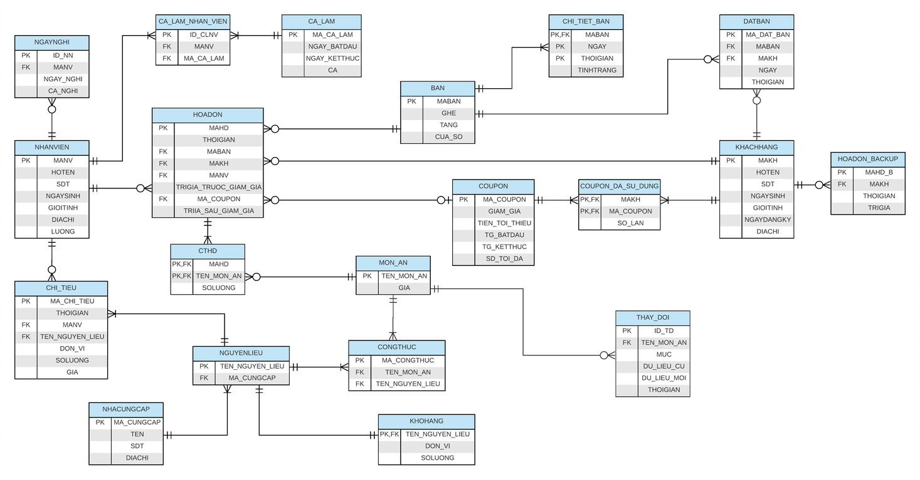

## **4. Job description**

- Organize shifts  
 - Check reservations  
 - Set up promotions  
 - Sales satistics   
 - Customers statistics

- Bill automatization

## 

## **5. Select**

### *5.1 The most used table*

The restaurant will aggregate the number of seats of each table through the HOADON table and the BAN table. From there, choose the table with the highest frequency for the purpose if the customer wants to know which table is the best.  
 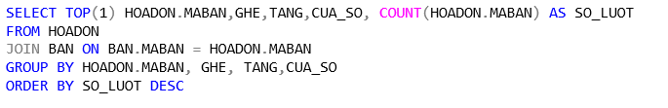

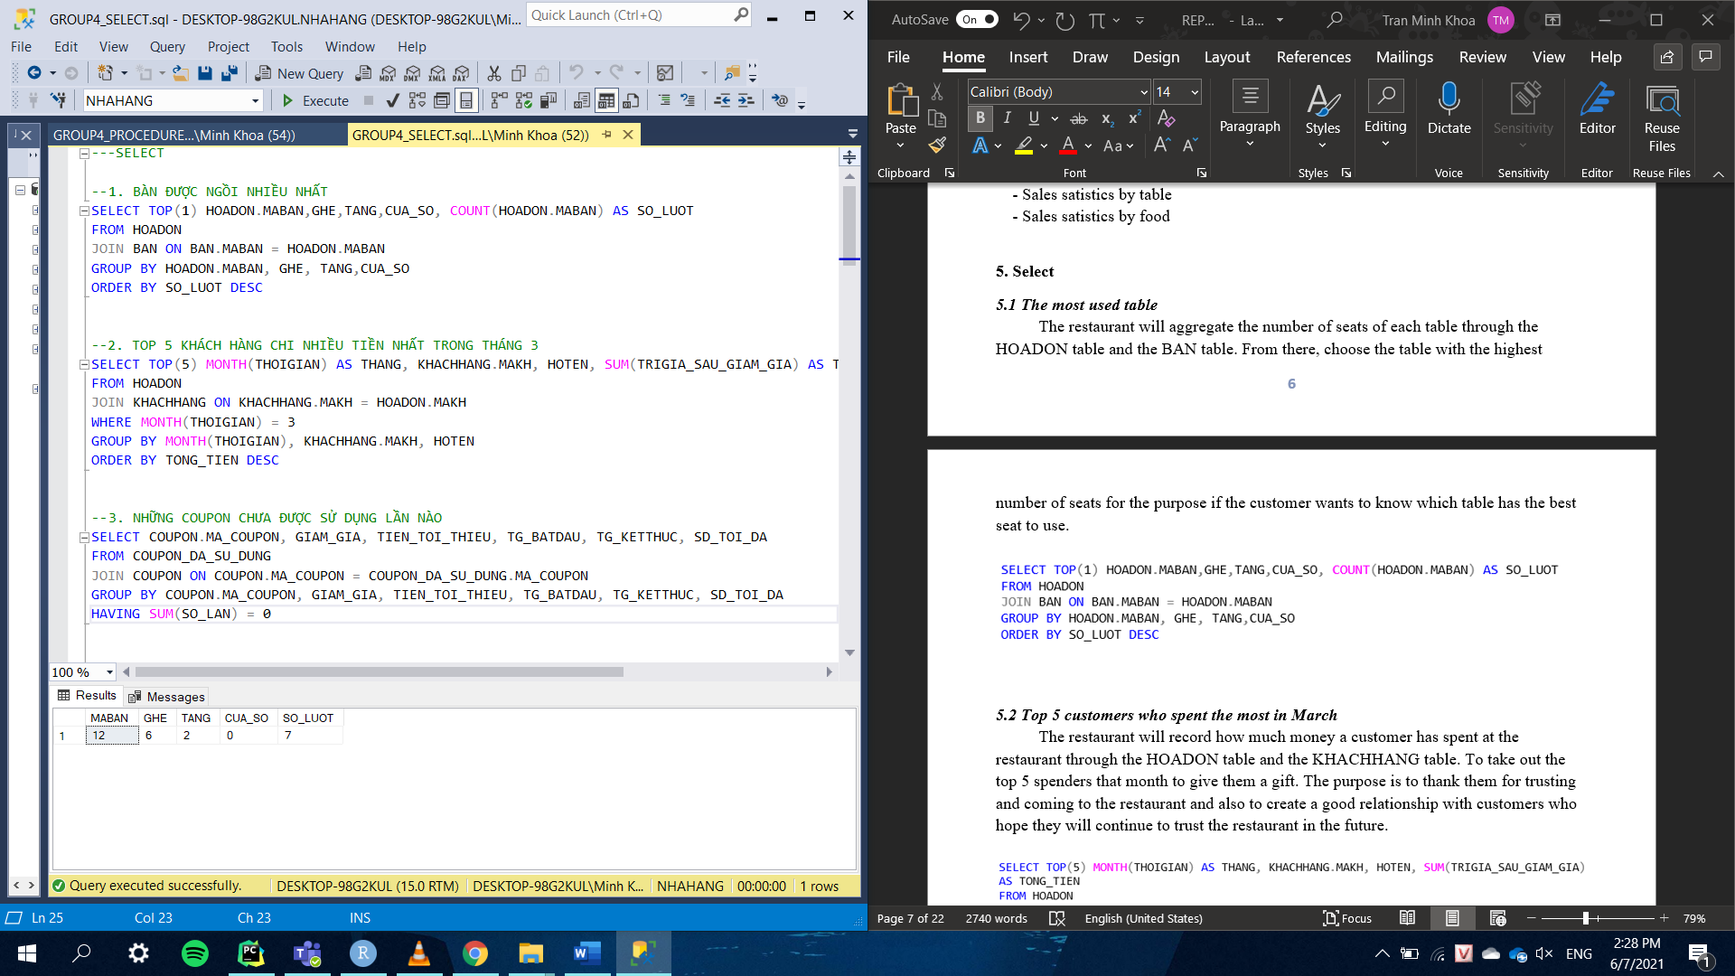

### *5.2 Top 5 customers who spent the most in March*

The restaurant will record how much money a customer has spent at the restaurant through the HOADON table and the KHACHHANG table. To take out the top 5 spenders that month to give them a gift. The purpose is to thank them for trusting and coming to the restaurant and also to create a good relationship with customers and hope they will continue to trust the restaurant in the future.

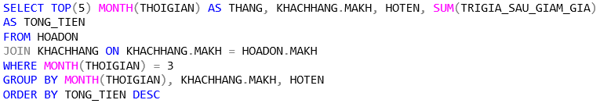

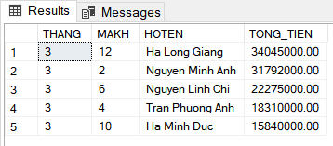

### *5.3 Coupons that have never been used*

To get experience from the promotions, the restaurant will find which coupons have never been used. To do that, you need to go through the COUPON table and the COUPON_DA_SU_DUNG table.

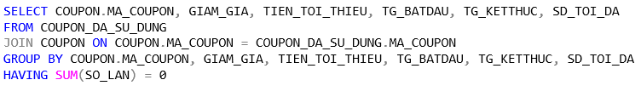

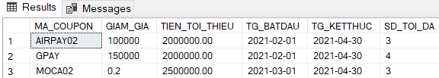

### *5.4 Most used coupons*

The restaurant wants to know which coupon code is used the most to plan a promotion next month. The result is taken from the HOADON and COUPON table.

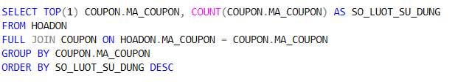

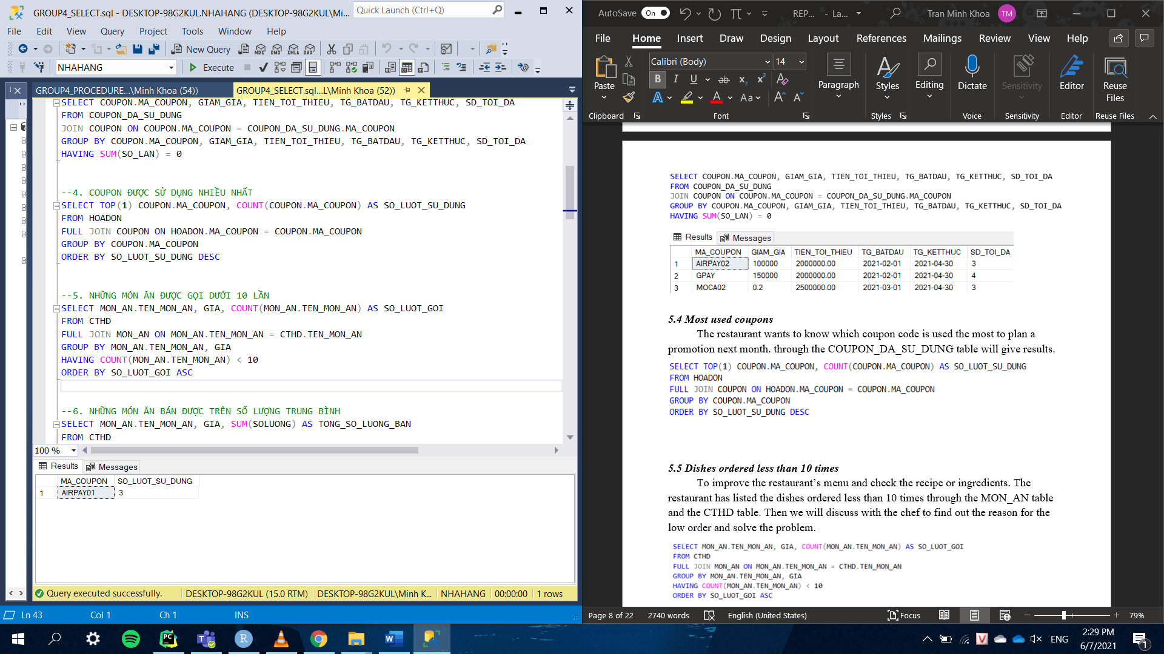

### *5.5 Dishes ordered less than 10 times*

To improve the restaurant’s menu and check the recipe or ingredients. The restaurant has listed the dishes ordered less than 10 times through the MON_AN table and the CTHD table. Then we will discuss with the chef to find out the reason for the low number of orders and solve the problem.

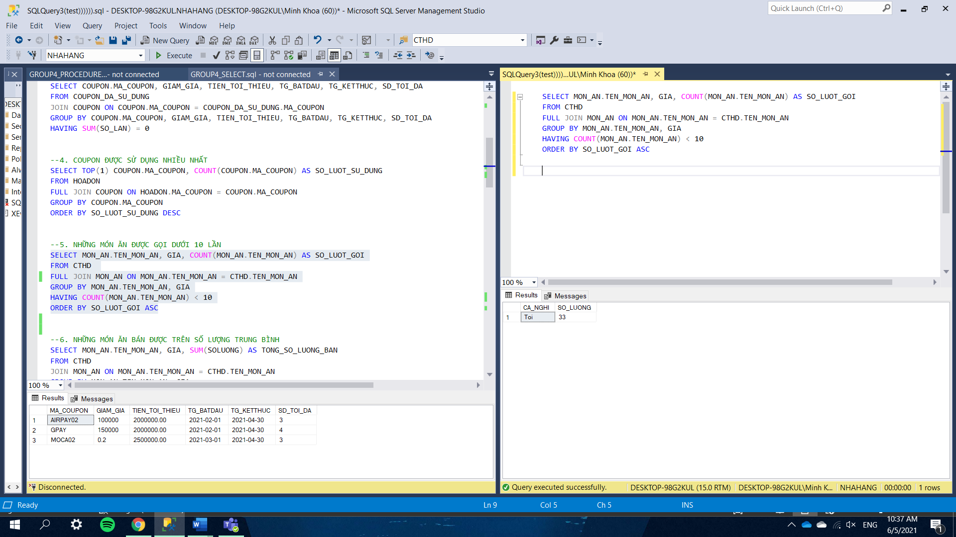

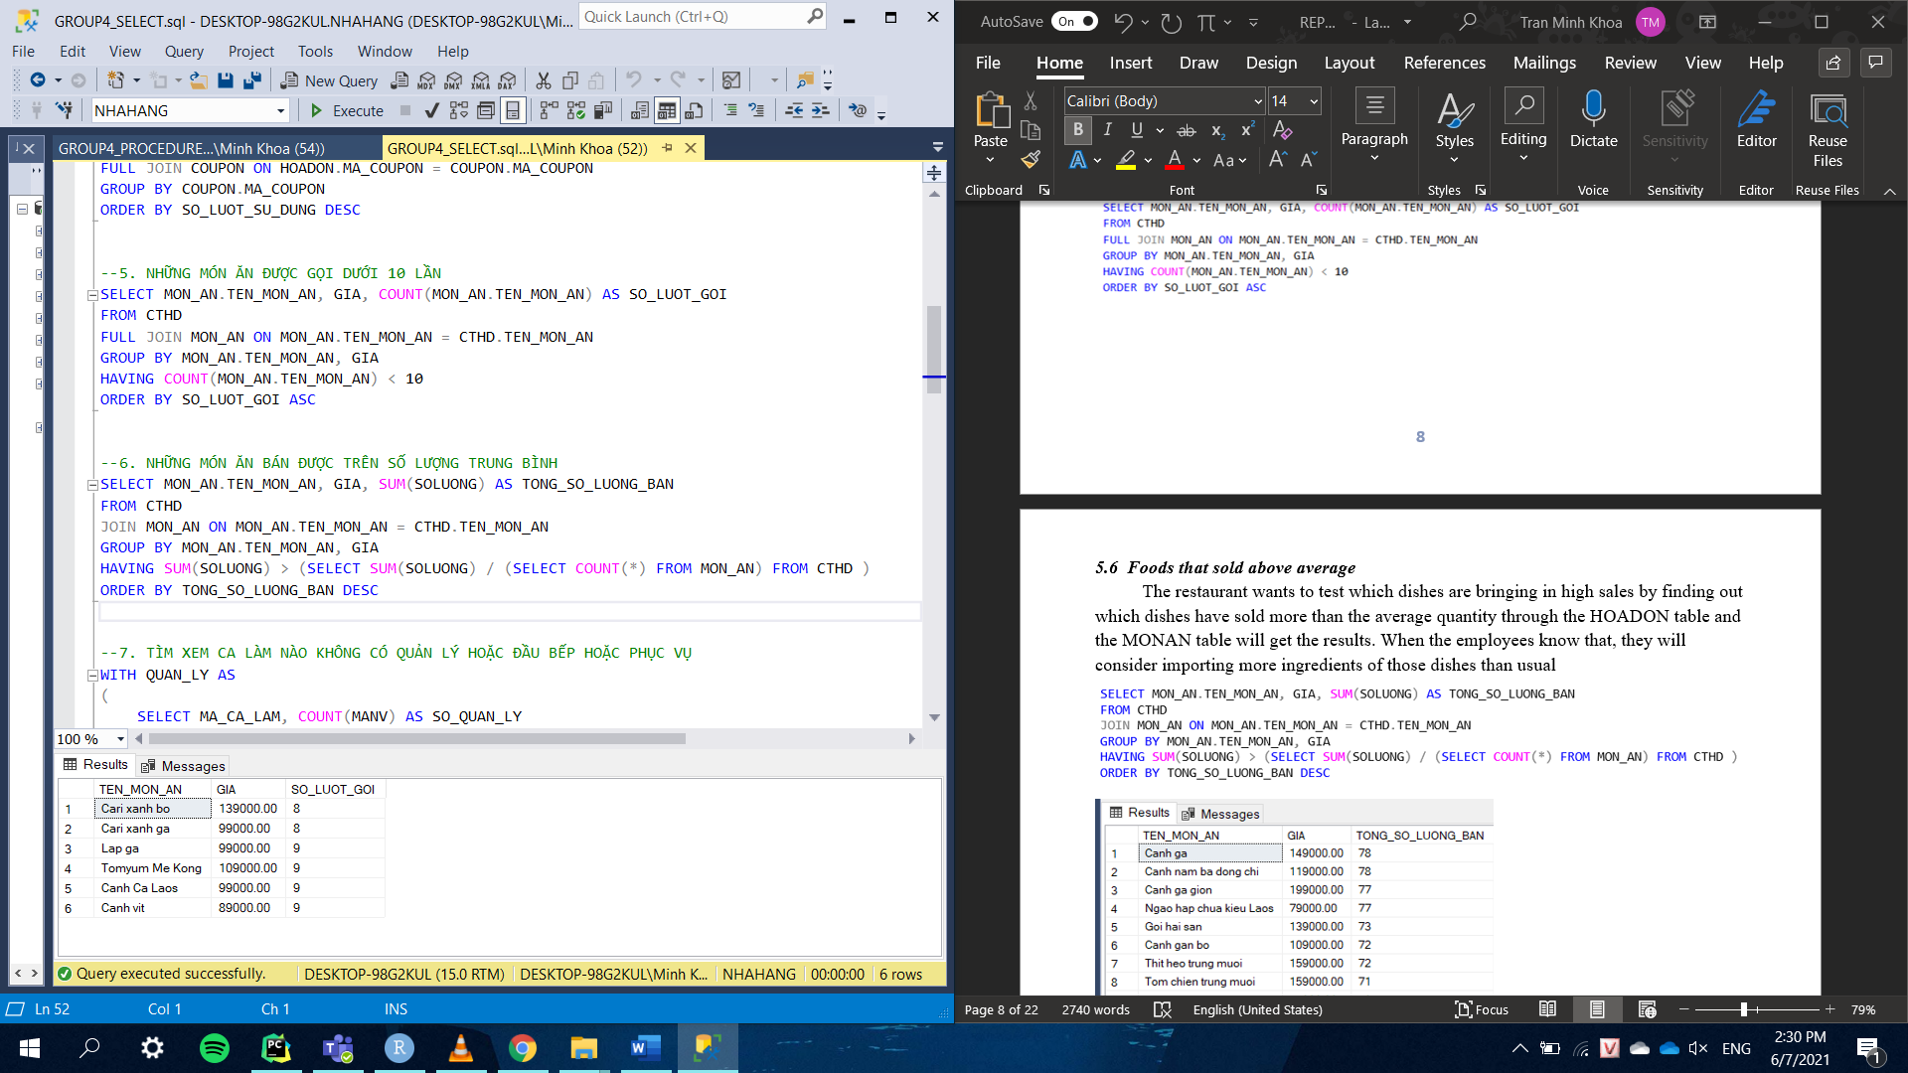

### *5.6 Foods that sold above average*

The restaurant wants to test which dishes are bringing in high sales by finding out which have been sold more than the average quantity through the HOADON table and the MONAN table. When the employees know that, they will consider importing more ingredients of those dishes than usual.

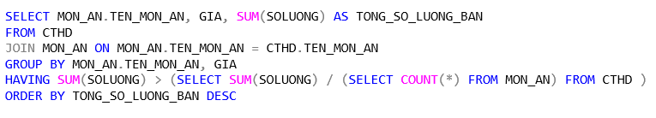

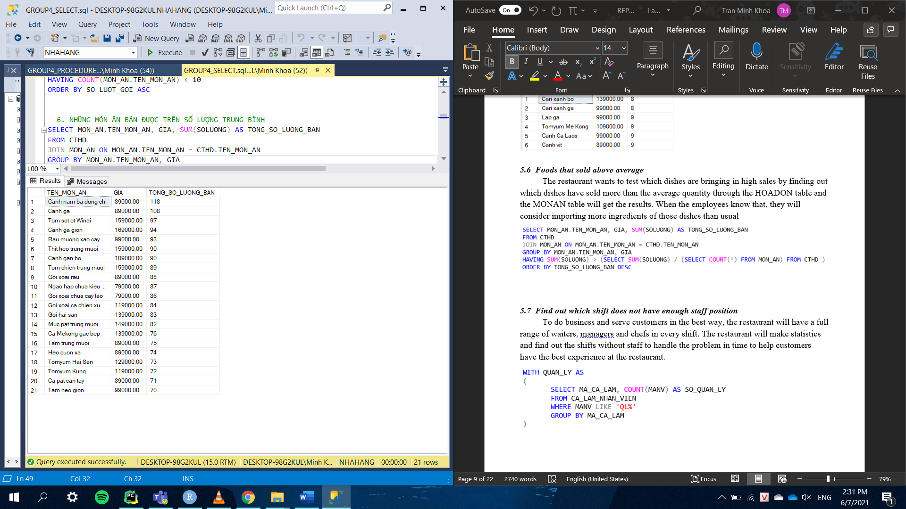

### *5.7 Find out which shift does not have enough staff positions*

To do business and serve customers in the best way, the restaurant must have a full range of waiters, managers and chefs in every shift. The restaurant will make statistics and find out the shifts without staff to handle the problem in time to help customers have the best experience at the restaurant.

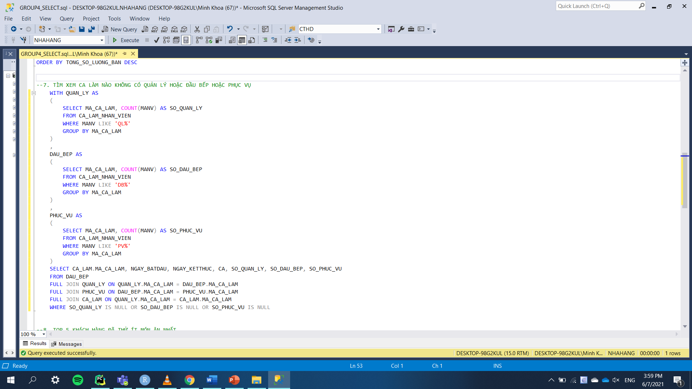

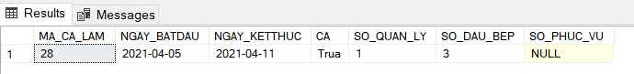

### *5.8 Top 5 customers that tried the fewest dishes at the restaurant*

To serve and help customers have the best service. The restaurant has counted the customers who try the fewest dishes to introduce them new dishes in the restaurant. To do that, they will have to go through the table CTHD and table MON_AN.

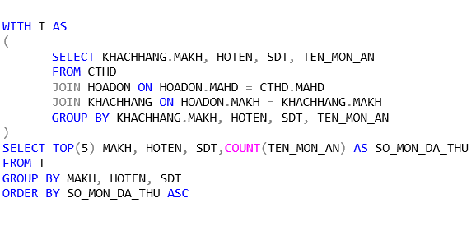

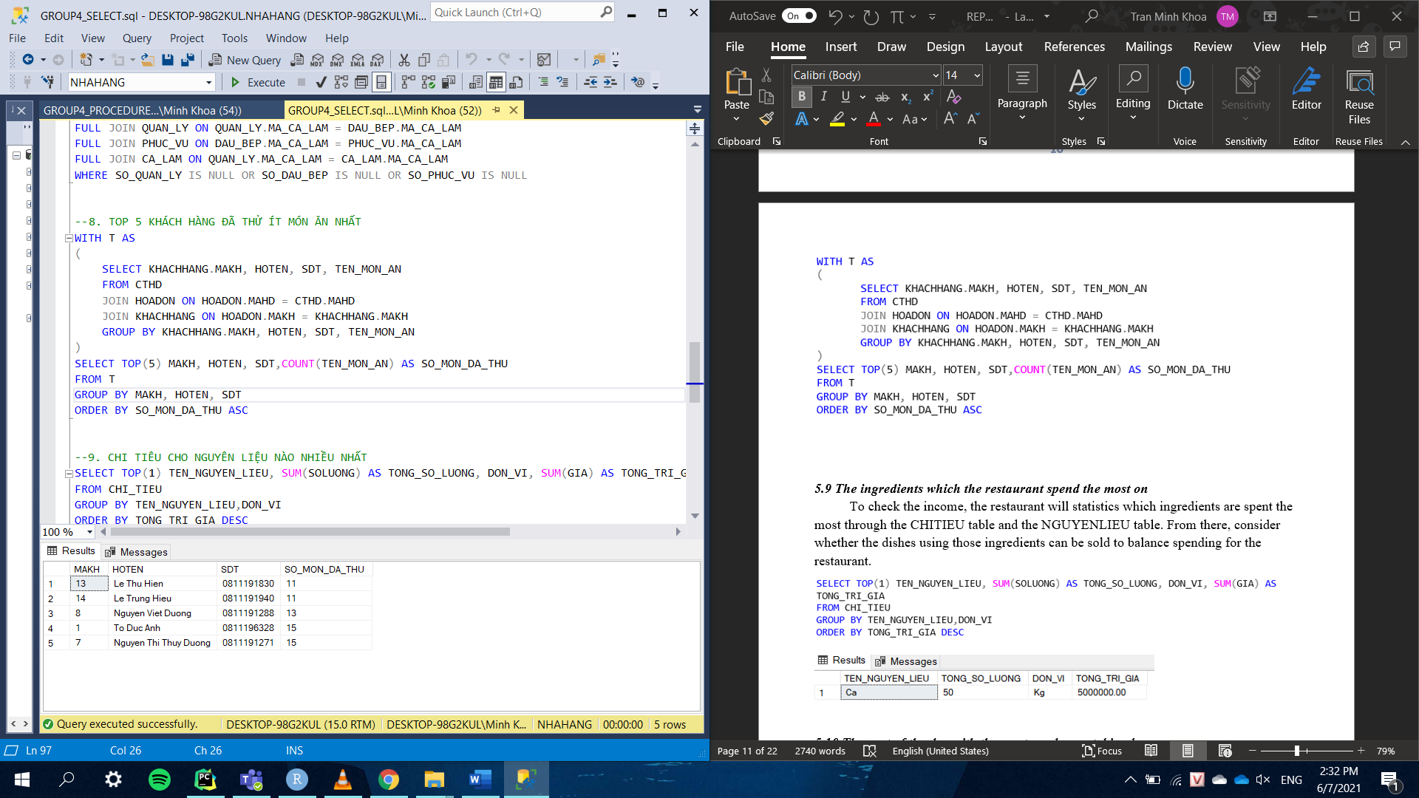

### *5.9 The ingredients which the restaurant spend the most on*

To check the income, the restaurant will statistics which ingredients are spent the most through the CHITIEU table and the NGUYENLIEU table. From there, consider whether the dishes using those ingredients can be sold to balance spending for the restaurant.

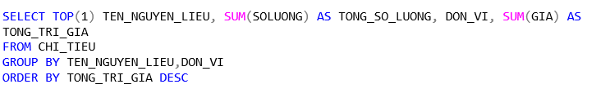

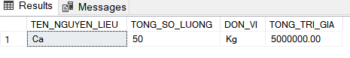

### *5.10 The part of the day with the most employees taking leave*

In order not to be short of employees, the restaurant will control their days off. The restaurant will check the part of the day with the most employees off through the NGAYNGHI table to arrange employees to make up that shift for better management and service.

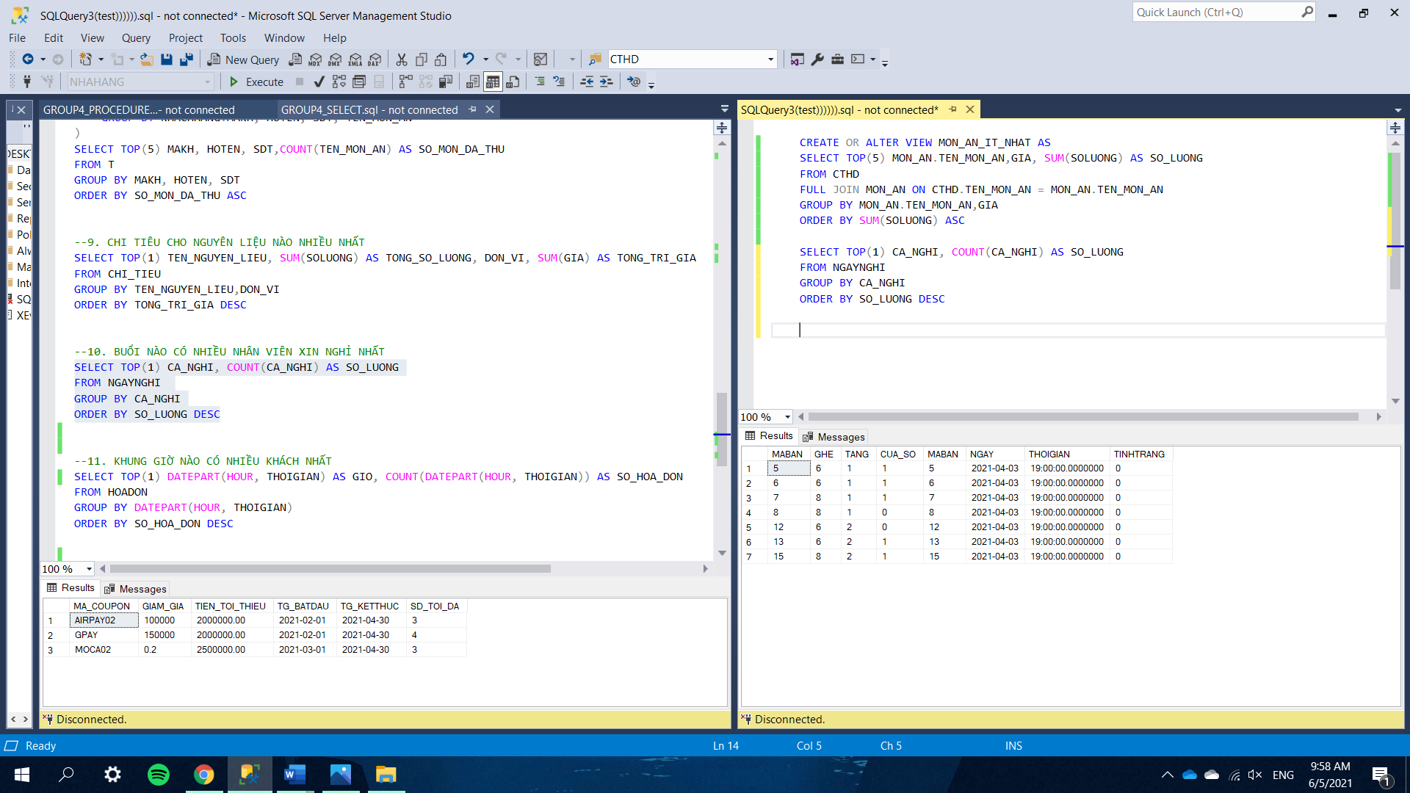

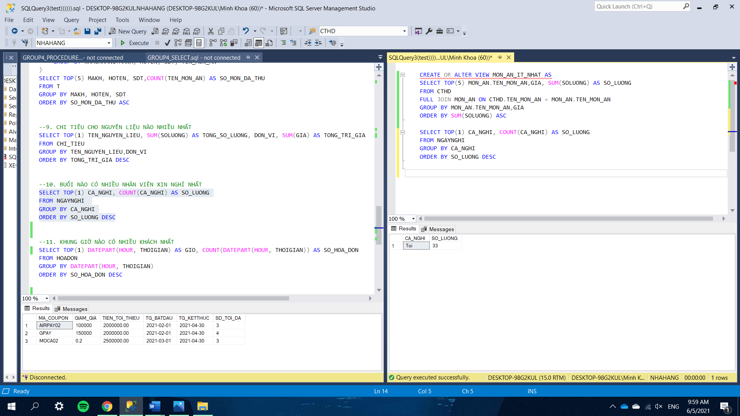

### *5.11 The period with the most visitors*

The restaurant statistics the period with the most customers through the HOADON table to increase the number of employees for that period. That helps customers to not wait too long and be satisfied with the service of the restaurant.

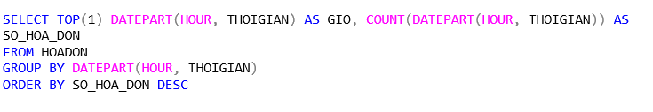

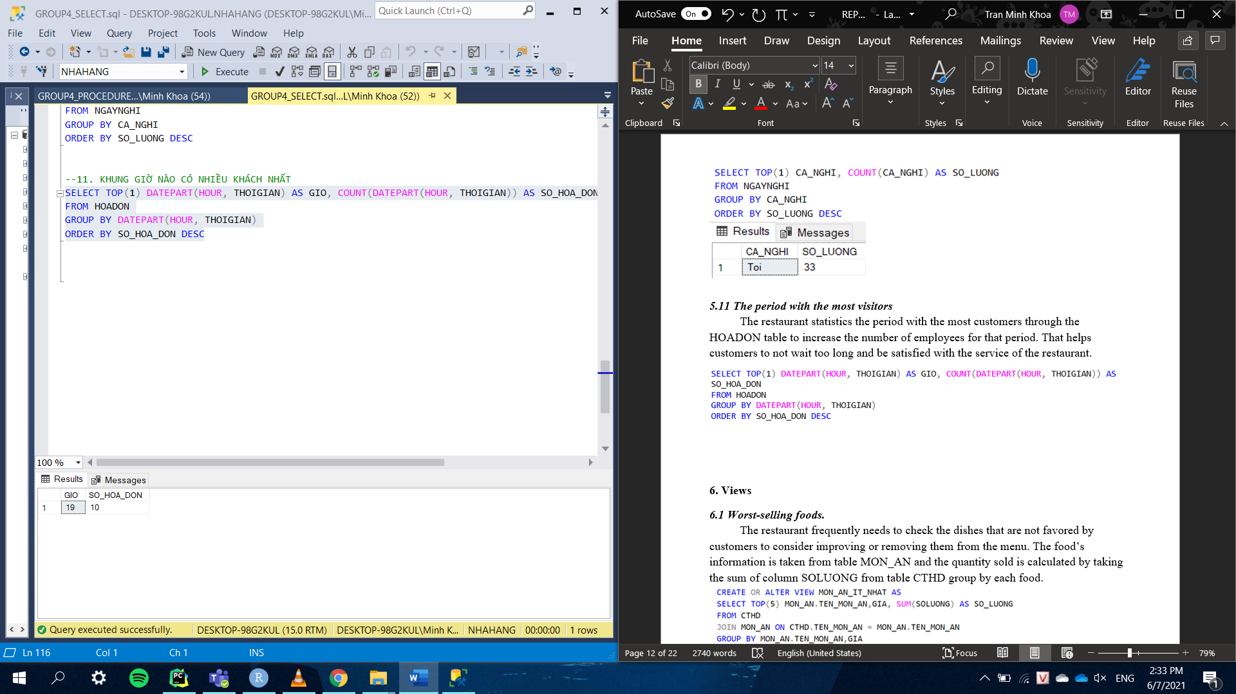

## **6.** **Views**

### *6.1 Worst-selling foods.*

The restaurant frequently needs to check the dishes that are not favored by customers to consider improving or removing them from the menu. The food’s information is taken from table MON_AN and the quantity sold is calculated by taking the sum of column SOLUONG from table CTHD group by each food.

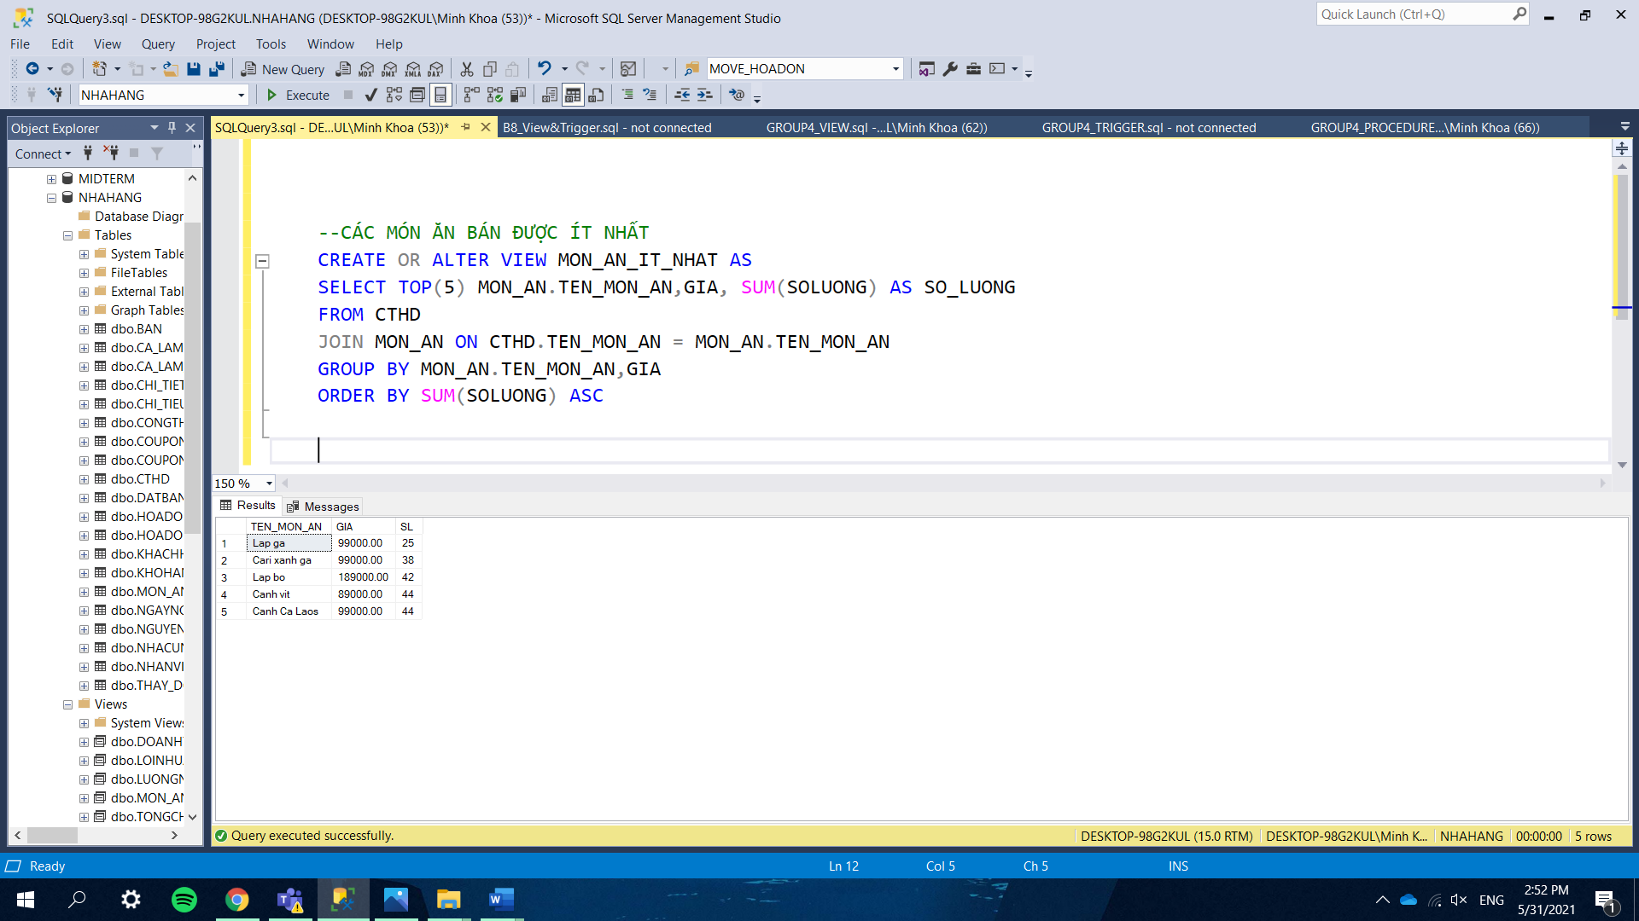

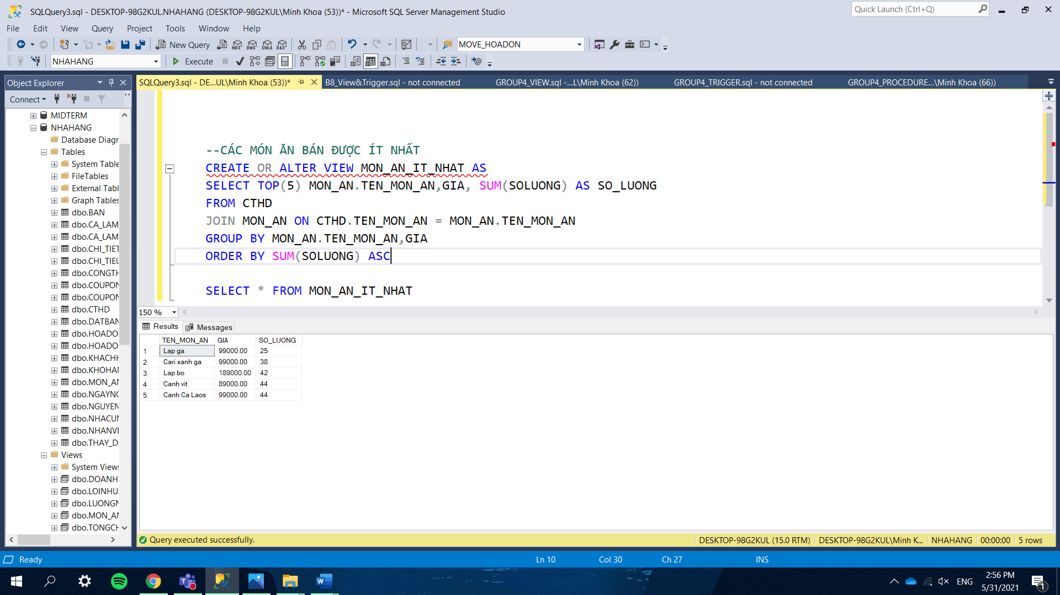

### *6.2 Ingredients that are used in most foods.*

We need to store this information in a specific view to know which ingredients are used regularly to import more to the warehouse. The number of dishes that use an ingredient is the number of times that it appears in the table CONGTHUC.

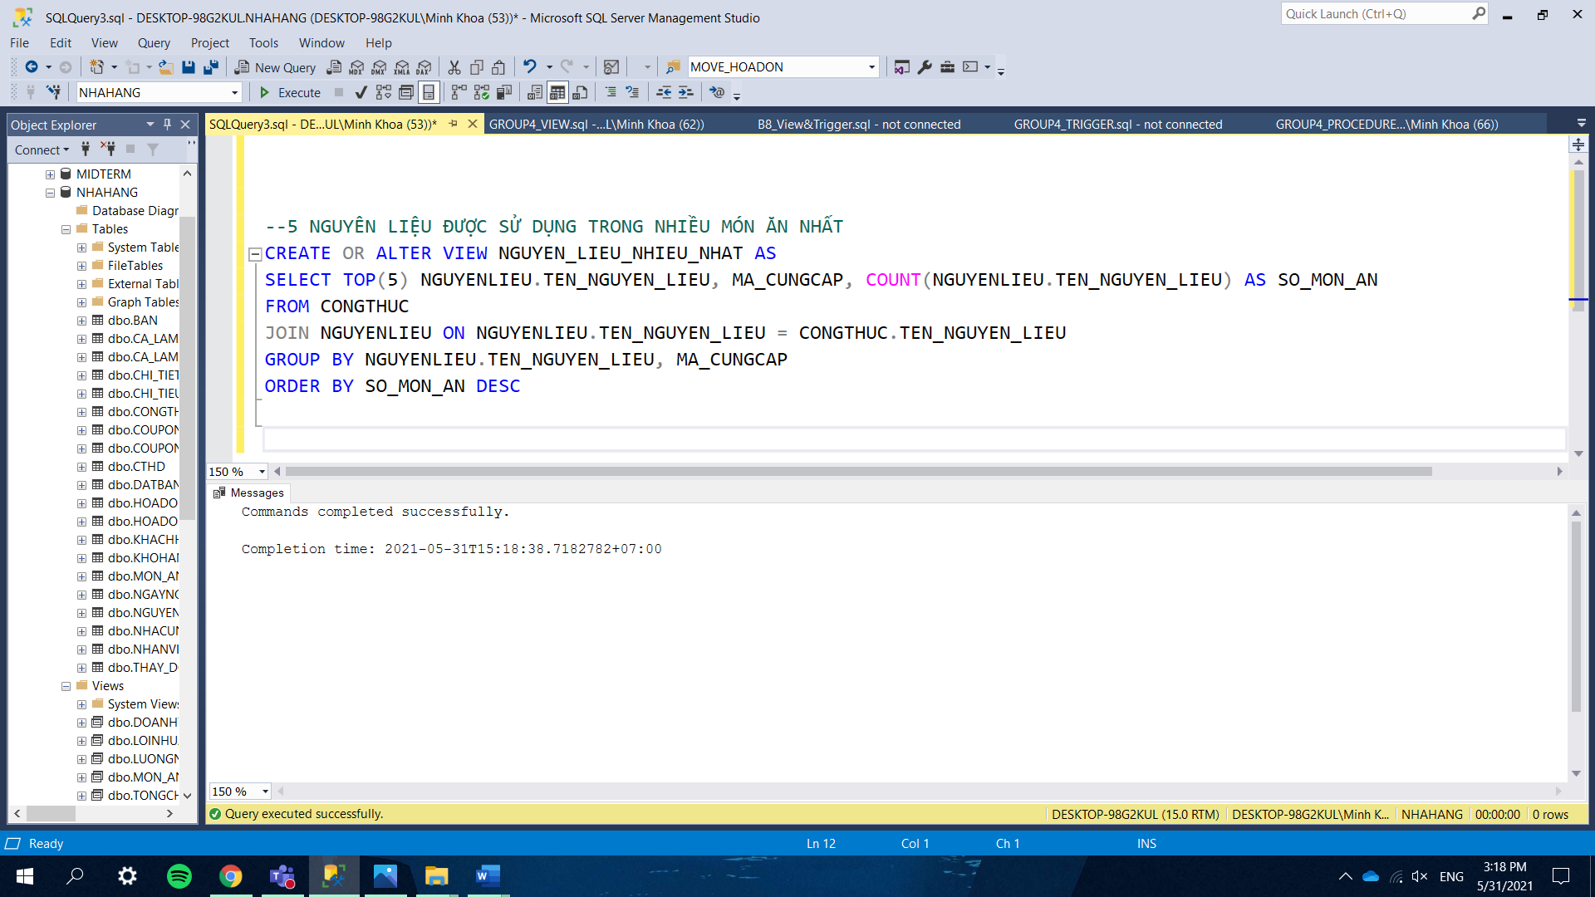

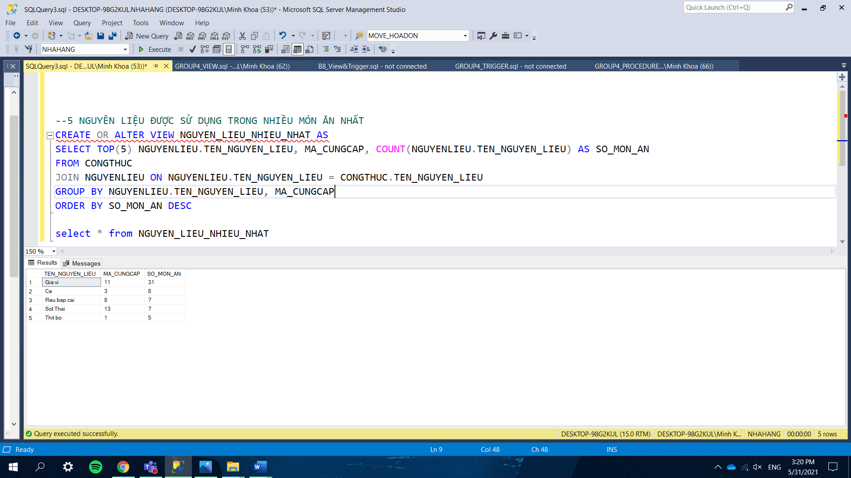

### *6.3 Revenue of each month.*

The monthly revenue is calculated by the sum of the bills’ value (after discount) group by year and month.

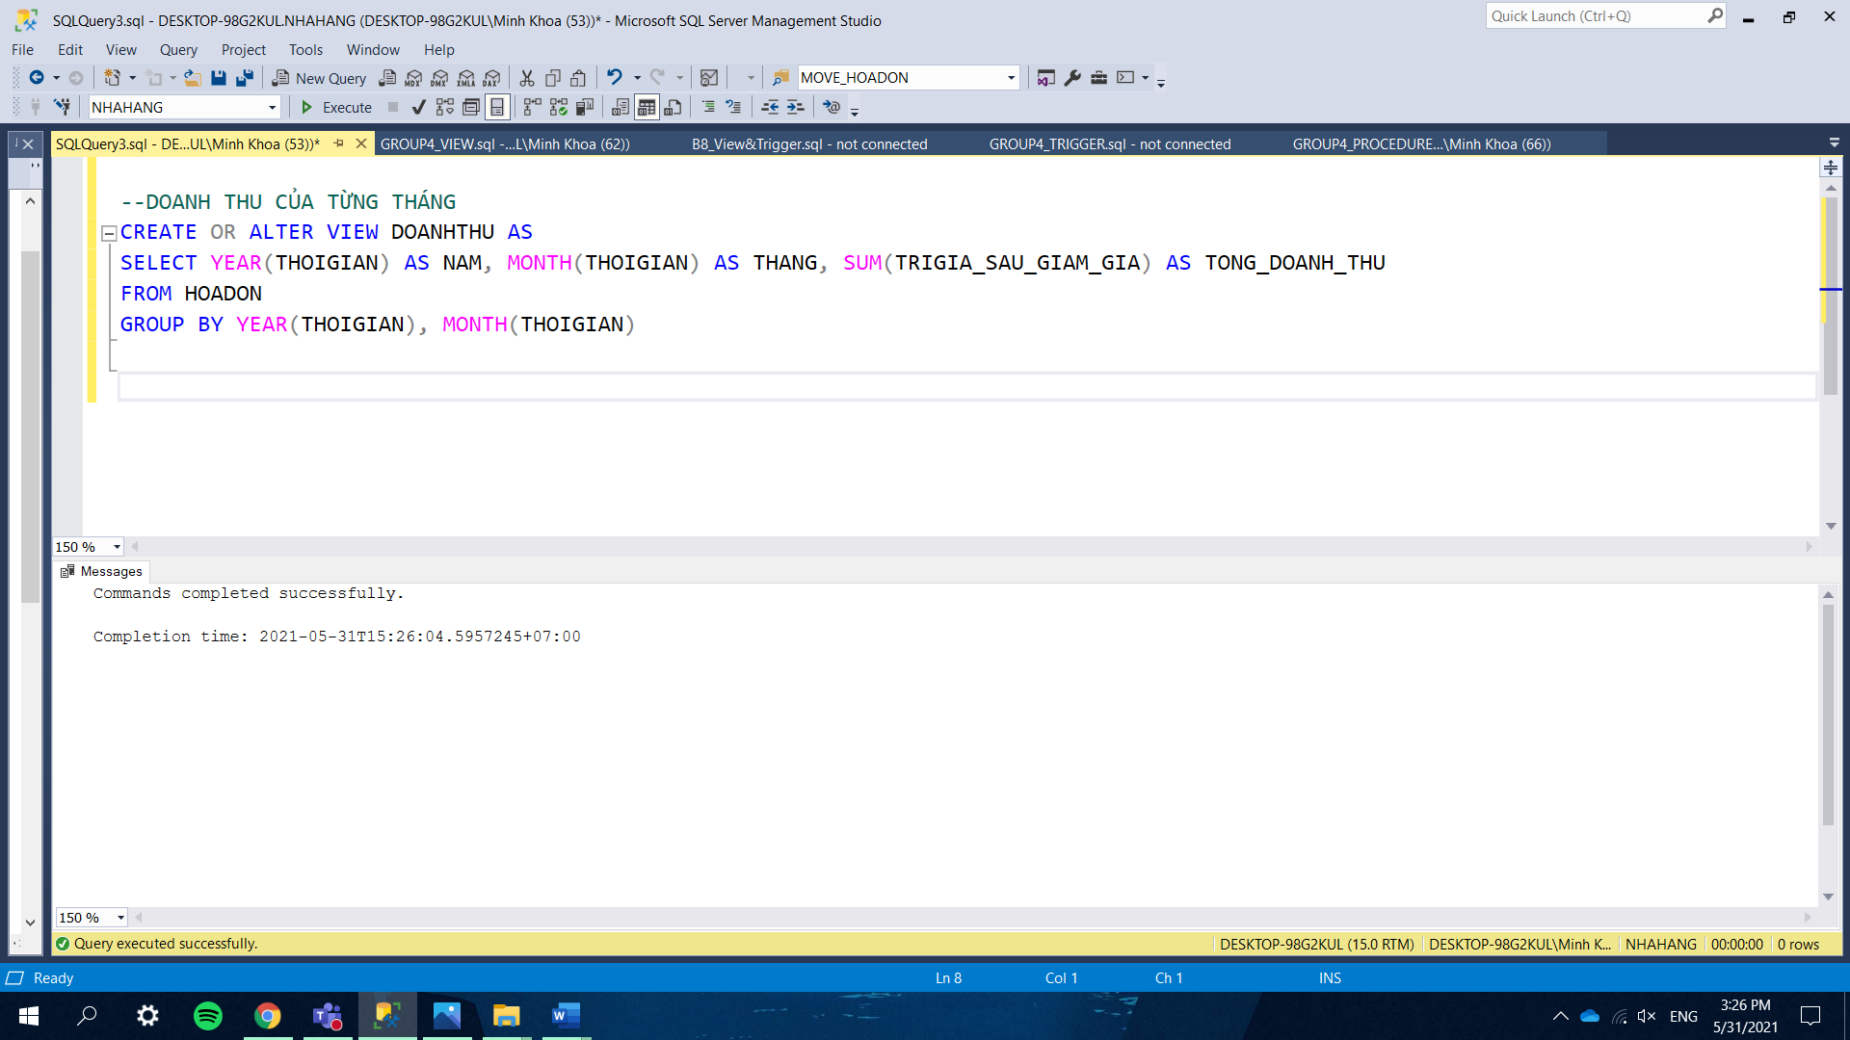

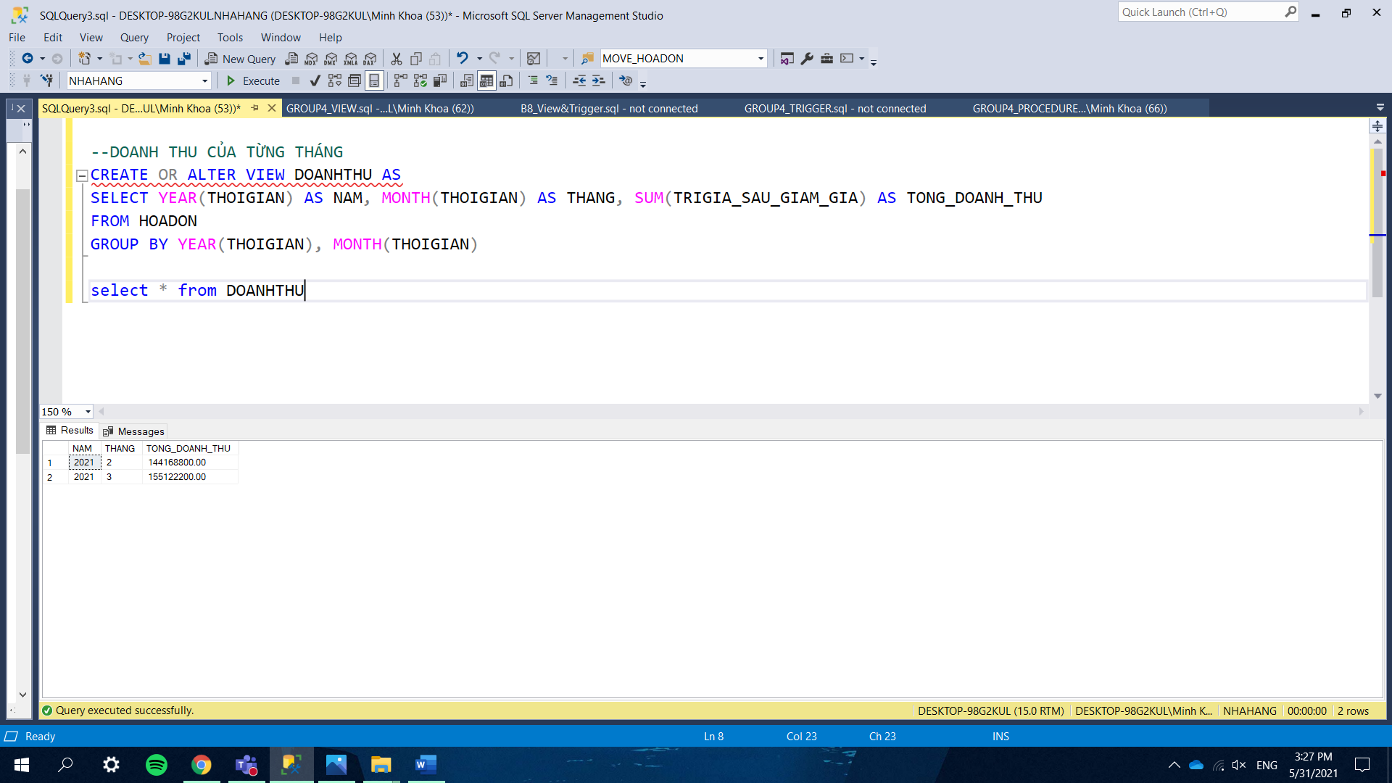

### *6.4 Total expense of each month.*

The monthly total spending is computed by the sum of the total price each time an employee buys an ingredient group by year and month.

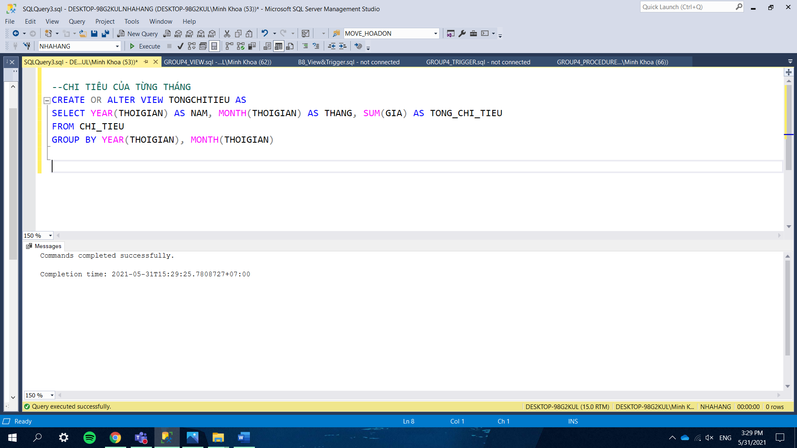

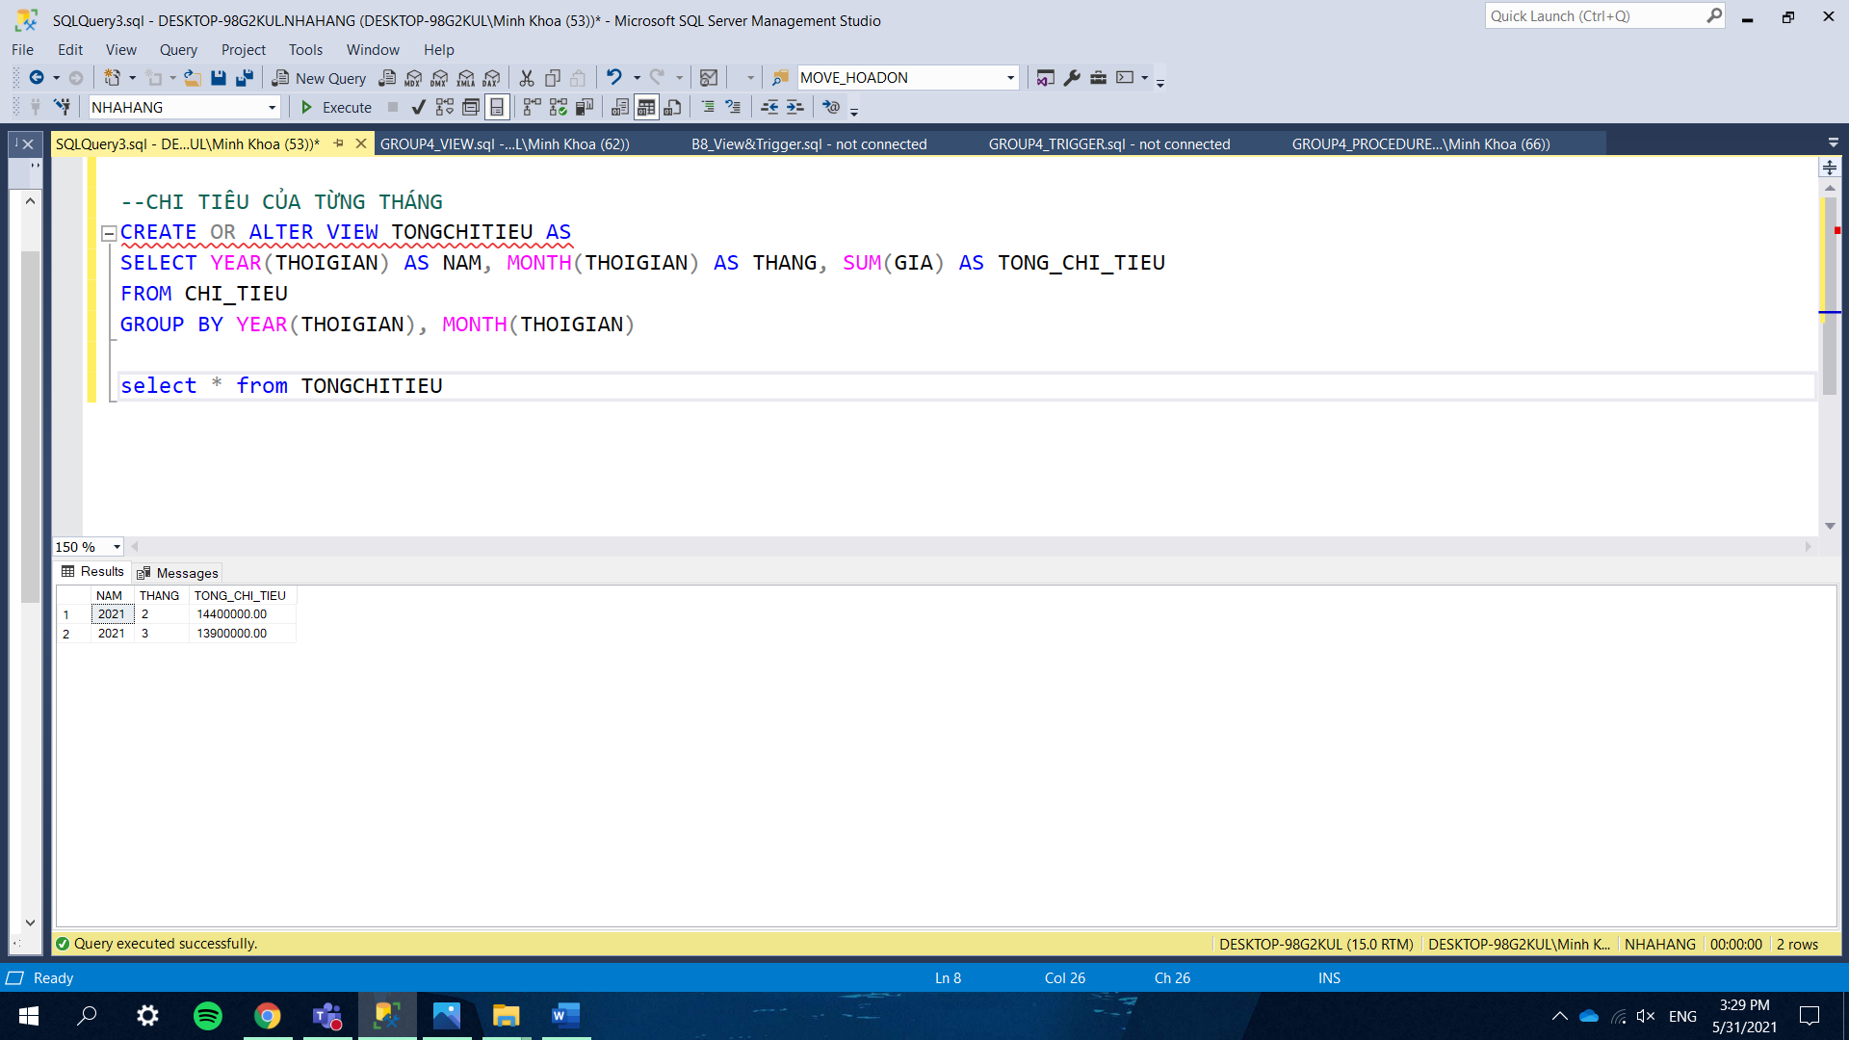

### *6.5 Employees’ salary.*

In order to compute the salary of each employee from different months; first, we create a Common Table Expression (CTE)-TONG_SO_CA_LAM to count the number of weeks each employee signed up for and multiply by 7 to get the number of shifts. Next, we create the second CTE- TONG_SO_CA_NGHI to get the number of shifts that each employee was absent. The number of shifts that the employees actually worked is the number of shifts that they signed up for minus the number of shifts that they were absent. Finally, we join those 2 CTEs with table NHANVIEN and multiply their salary by the number of shifts worked and group by year and month to get the final result.

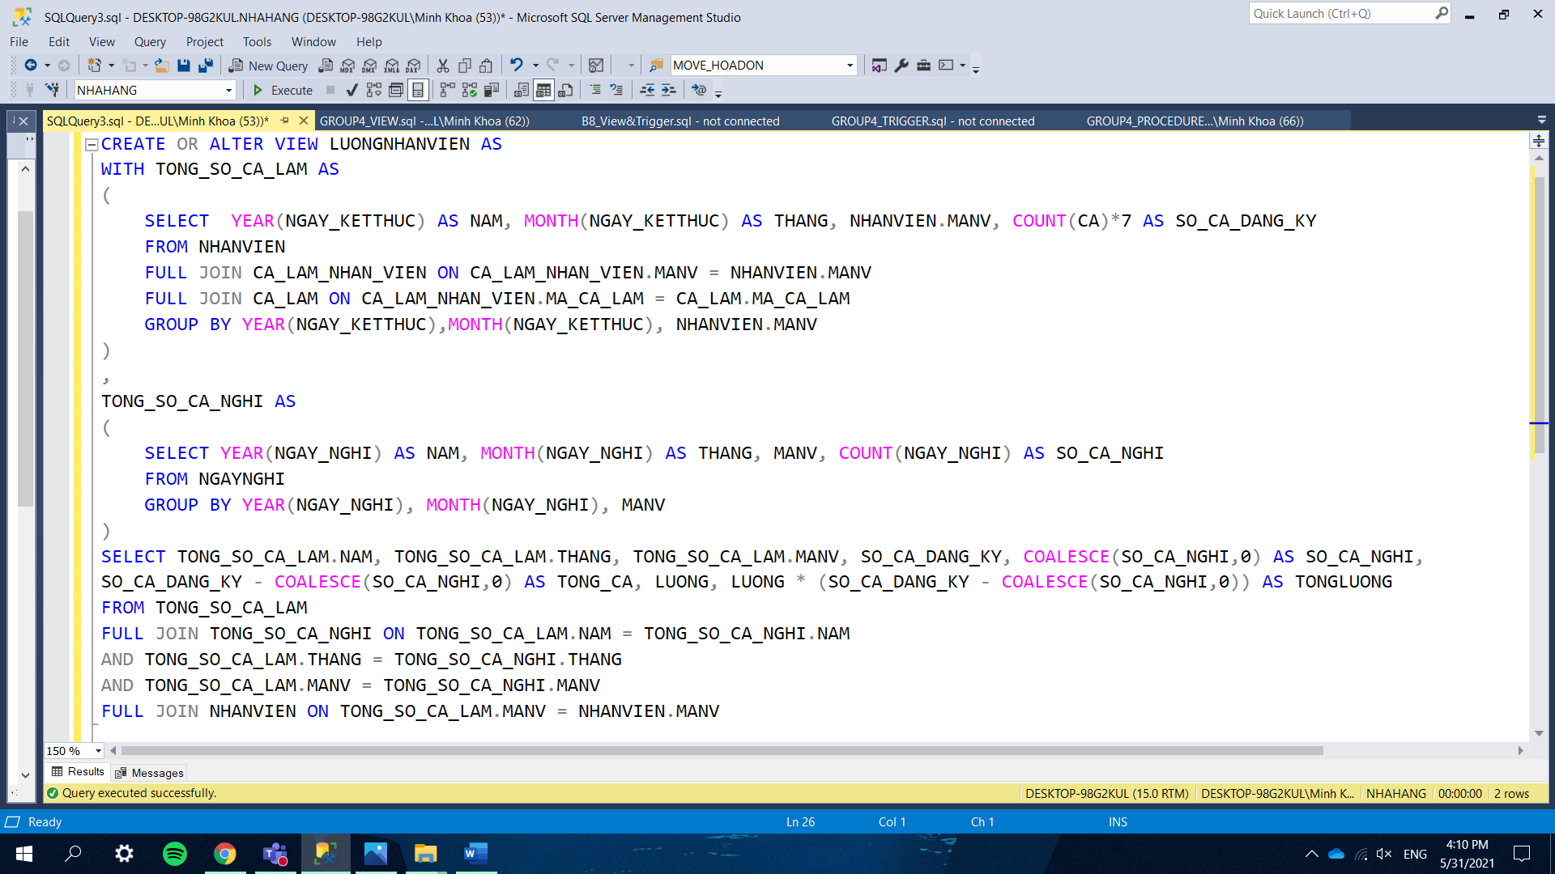

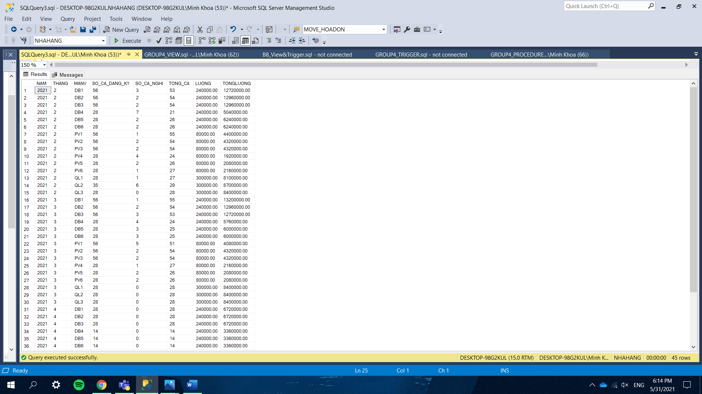

### *6.6 Profit of each month.*

The profit of the restaurant is simply the revenue minus salary and total expense. We created a CTE to get the sum of salary by each month and then join it with 2 views (TONGCHITIEU and DOANHTHU) which we created previously to get the final output.

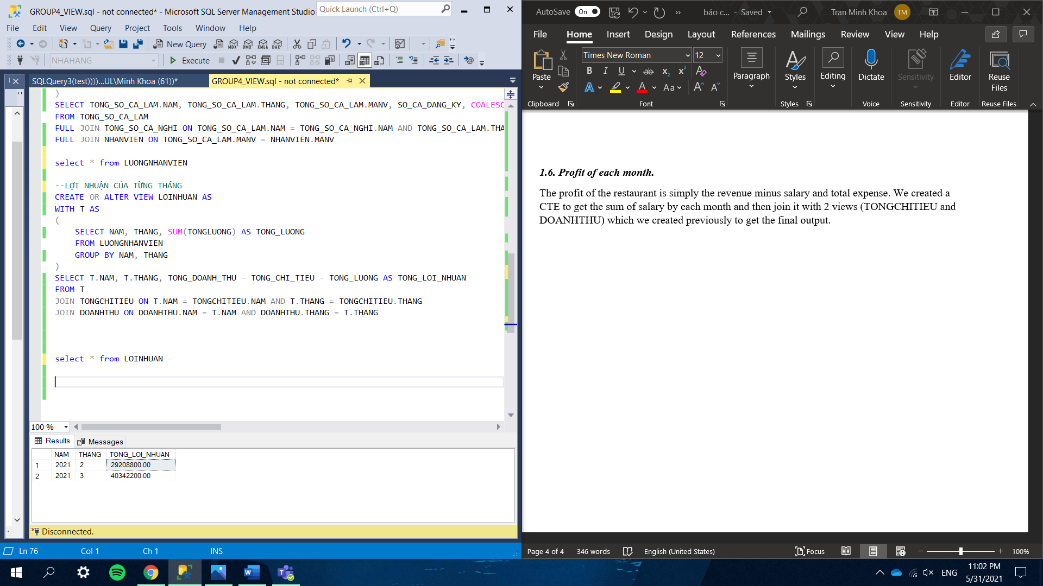

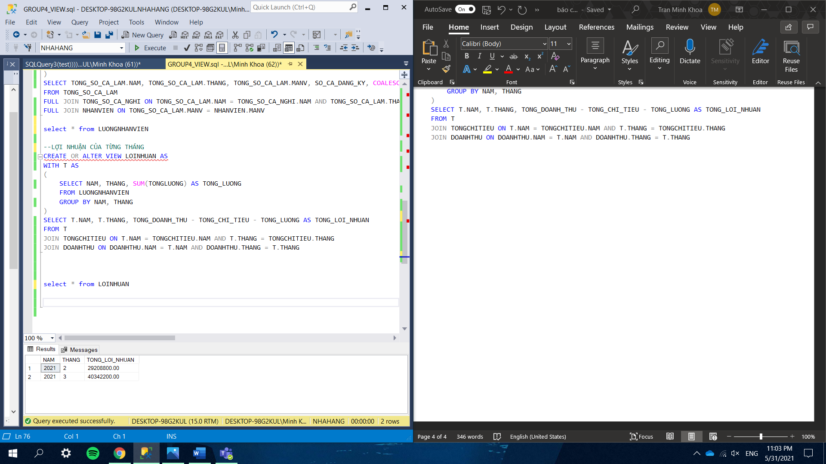

## **7. Procedures**

### *7.1 Search for available coupons.*

When a customer wants to use a coupon to pay the bill, the employees will execute a procedure to show all coupons that the customer is allowed to use. The input contains the time that the bill is generated, the value of the bill and the payment method (optional). The available coupon must satisfy the following conditions:

* The time of the bill must be in the time range of the coupon
* The total amount of the bill must be higher or equal to the minimum values required to use the coupon
* The time that the customer has used this coupon must be less than the maximum time

If the customer has a specific payment method, the procedure will search for the coupons that have the coupon code contains the substring payment method. Otherwise, it will show all the coupons available.

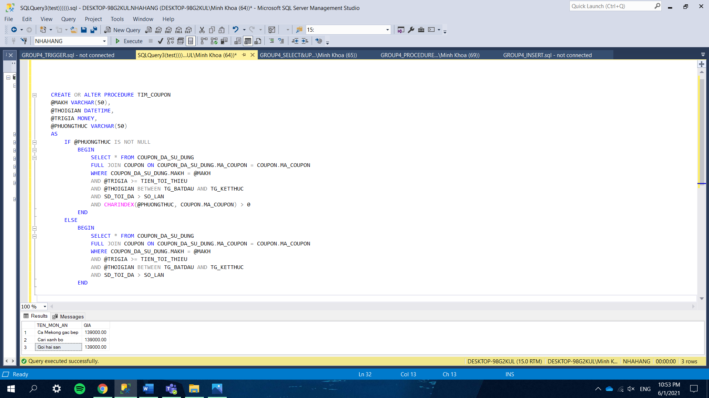

### *7.2 Search for employees in a specific shift.*

When the restaurant manager wants to find out which employees are in the shift in the noon, afternoon or evening of any day, this procedure will find the week that contains that day and search for the employees that signed up for the shift in that week but exclude the ones absent in the day that is searched for.

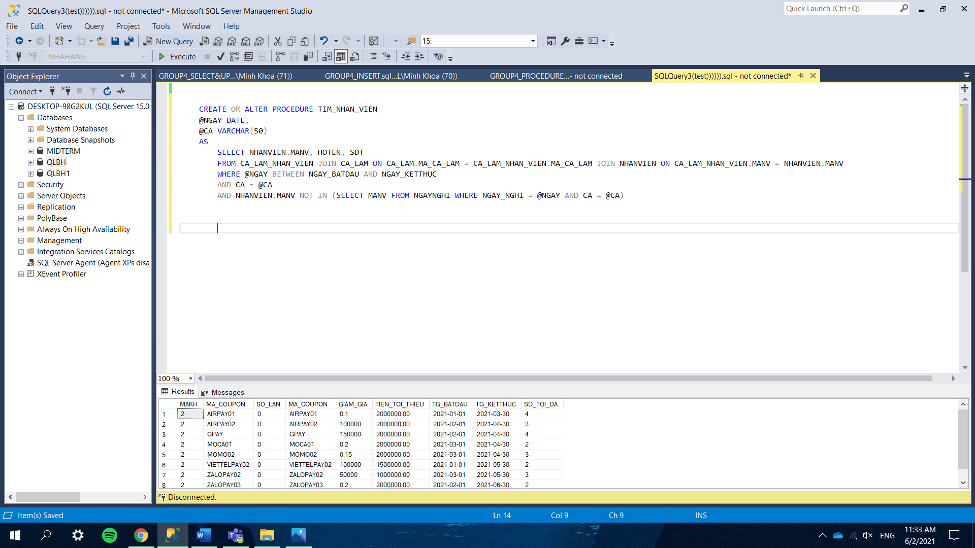

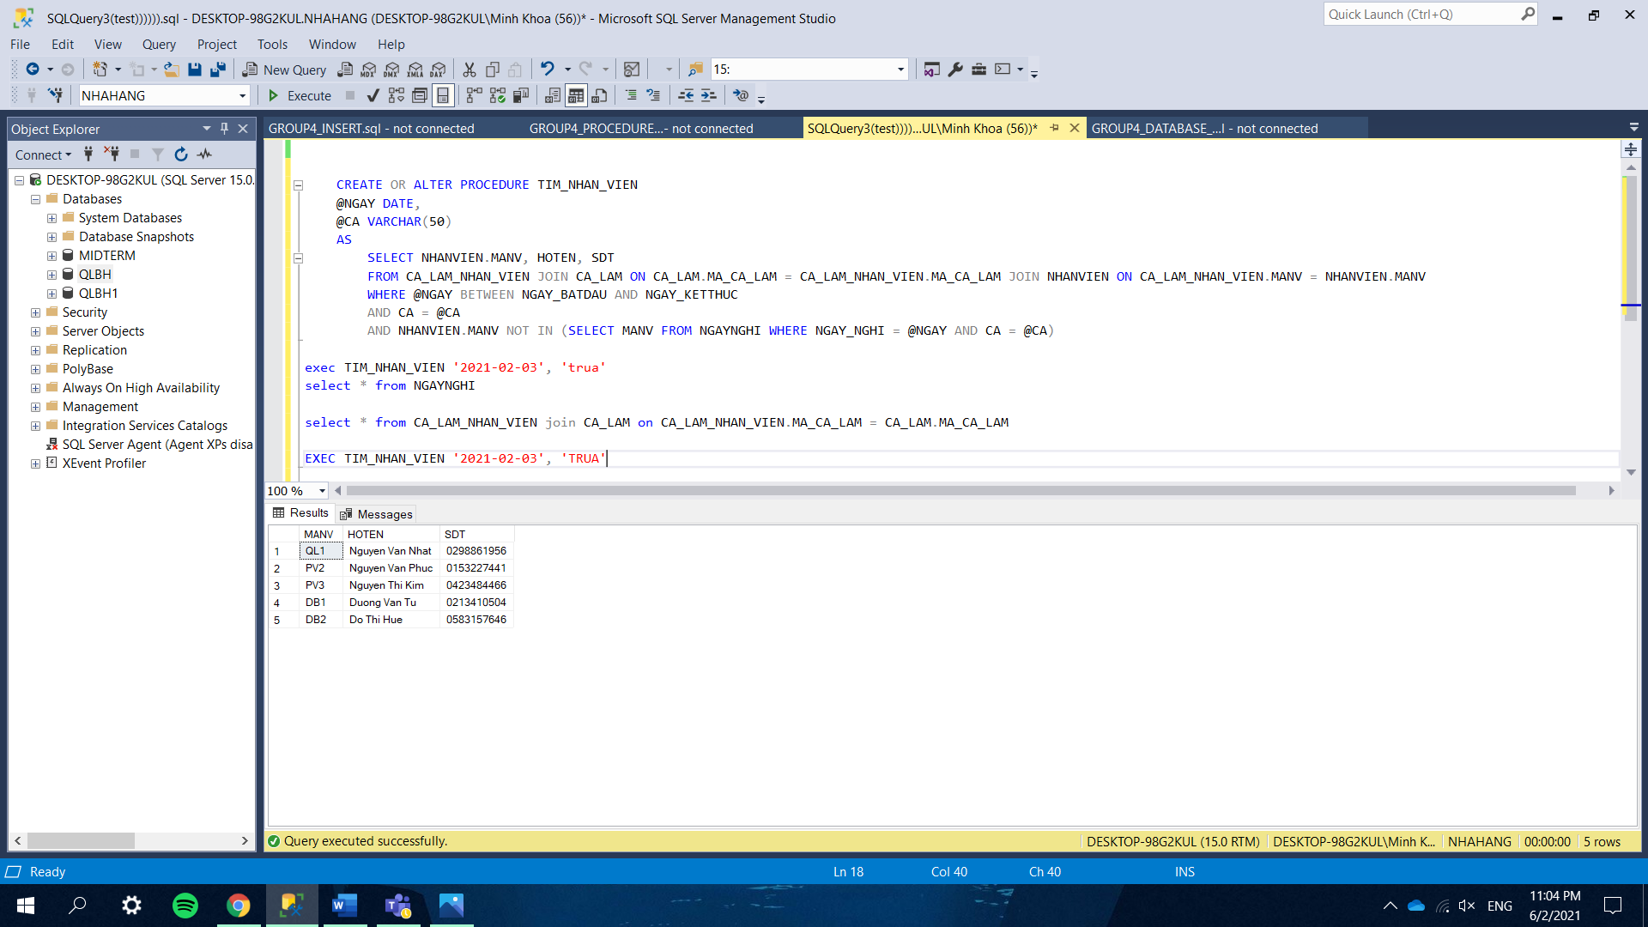

### *7.3 Move bills to the backup table.*

The bills created a long time ago usually contain information that is not necessary, so in order to save storage for the database, we should only keep the main information of those bills and move them to a new table. We do this by using a cursor to run through all the bills before the date that we choose. With each bill, only its time, the customer code and its final value are taken and inserted into the table HOADON_BACKUP. After that, the lines that belong to the bill (in table CTHD) and the bill itself will be deleted to free up space.

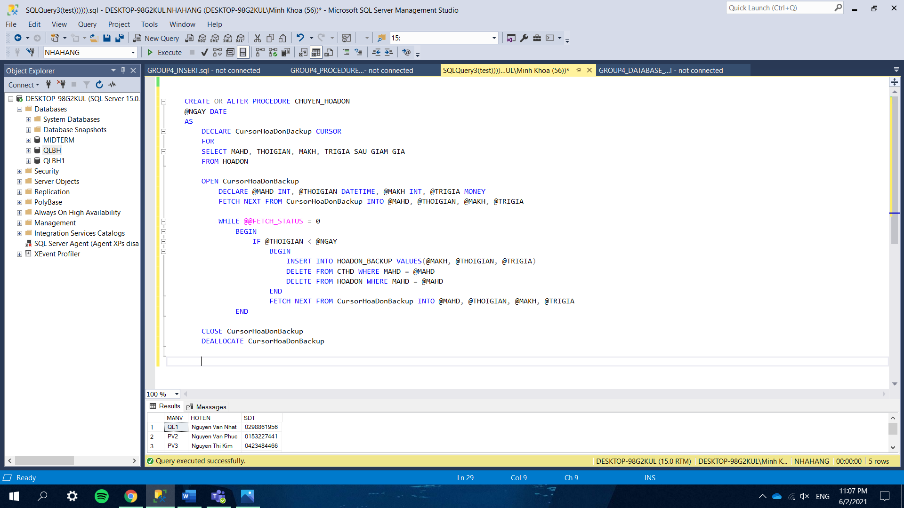

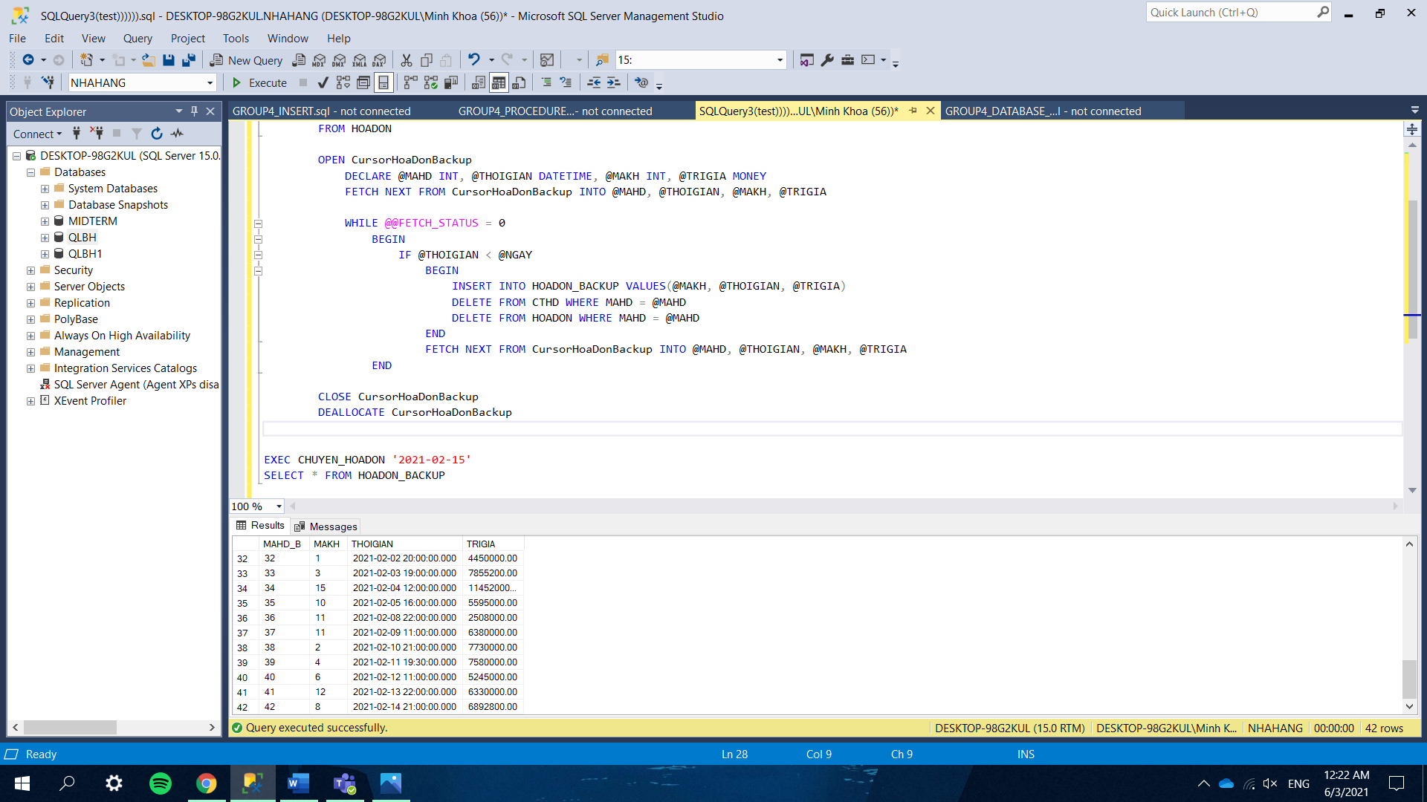

### *7.4 Increase the price of the best-selling dish.*

One of the easiest ways for the restaurant to earn more revenue is to raise the price of the food. However, if all the foods are too expensive, it might backfire and make the customers not wanting to come over again, so the optimal solution is to raise the price of one or a few dishes. Here, we only want to increase the price of the dish that has been sold with the highest quantity in the past, this procedure will find that dish in the table MON_AN and increase the price by the amount of the input number.

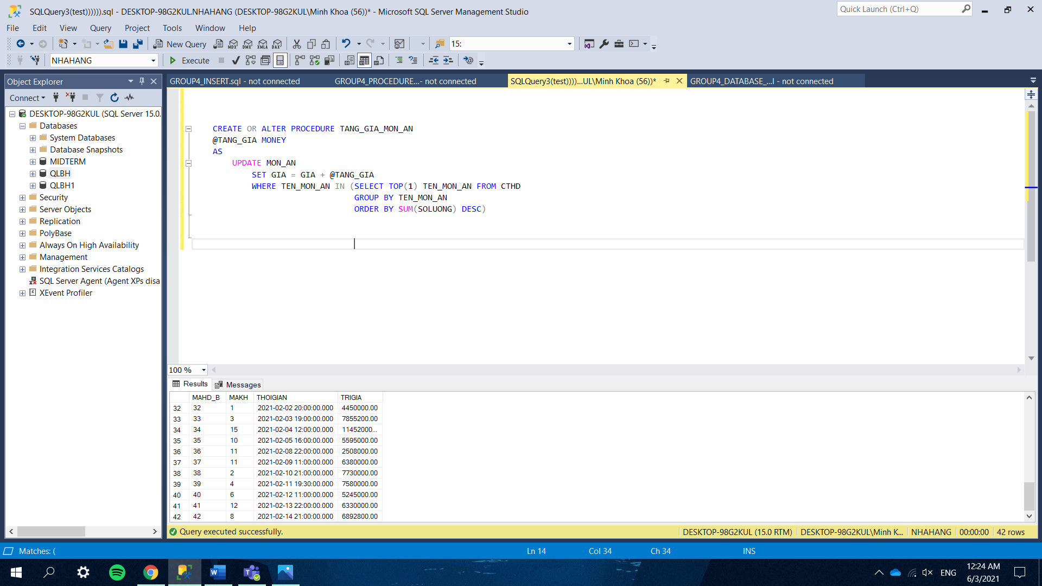

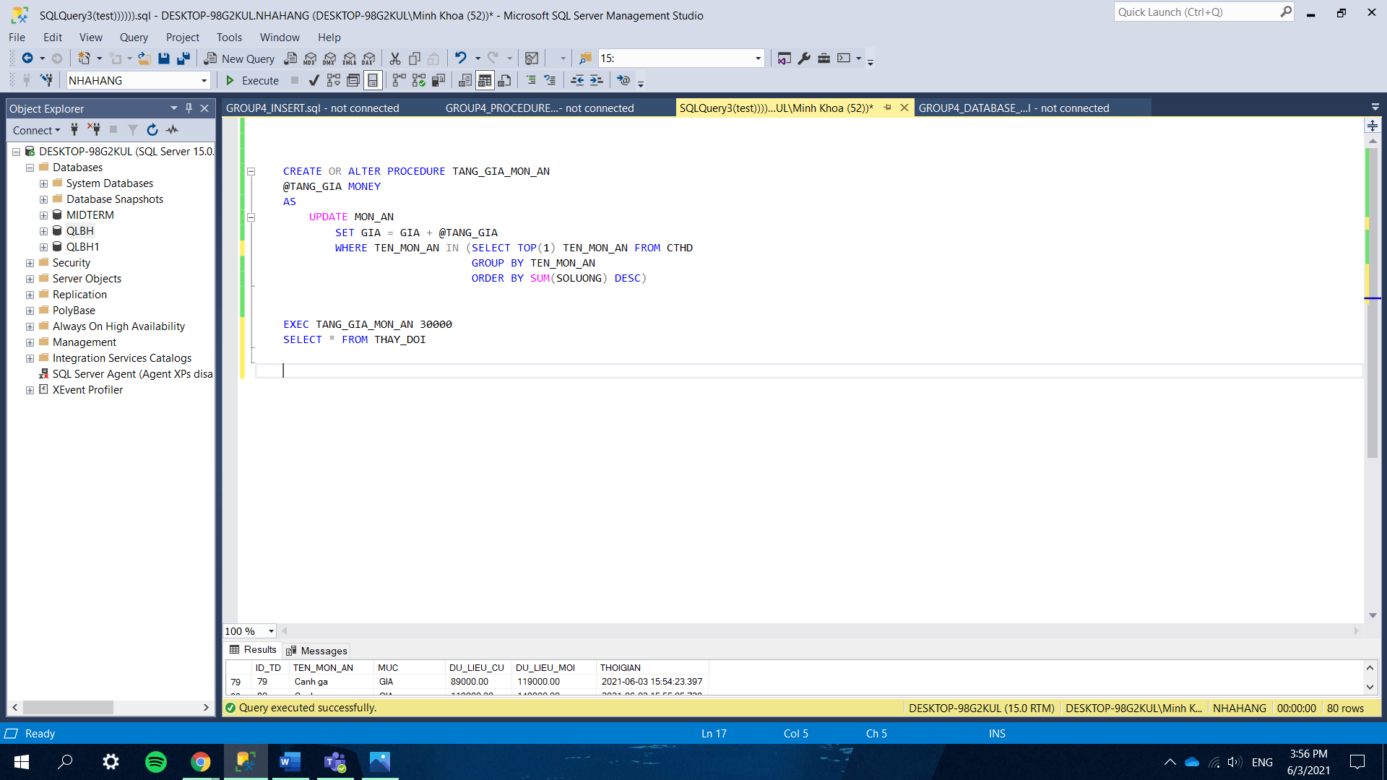



### *7.5 Find the tables available at a specific time.*

The tables in the restaurant can only have 2 statuses: 0 and 1 (unreserved and reserved respectively). This procedure takes the date and time from the input and finds the tables that have the status equal to 0. If the number of seats from the input is null, it will show all unreserved tables and otherwise, it will show the tables that have the number of seats equal or greater than the number required.

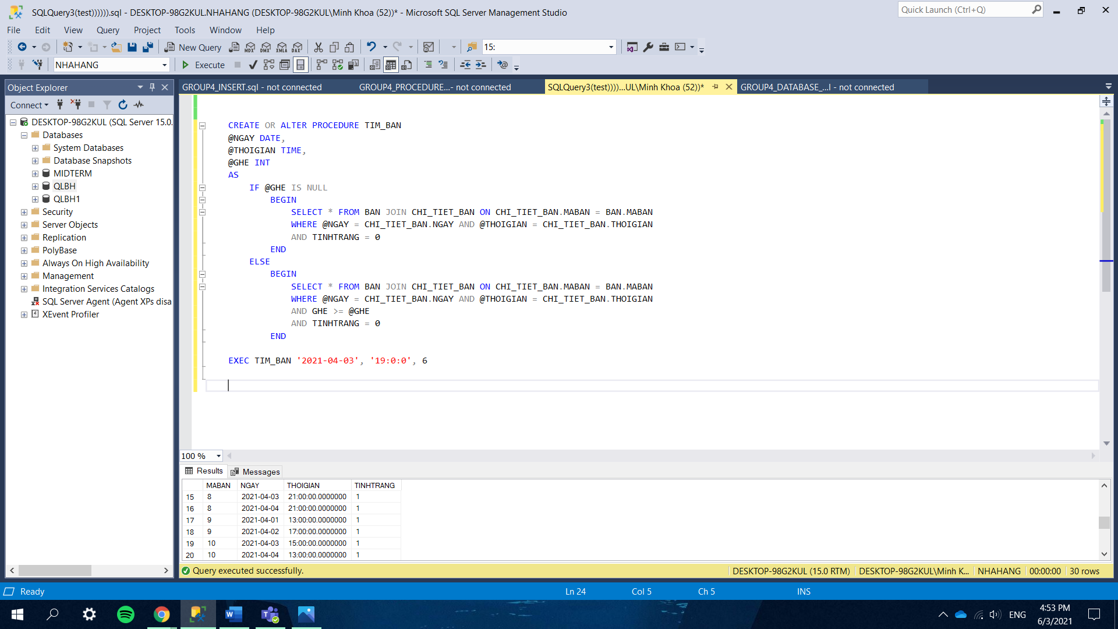

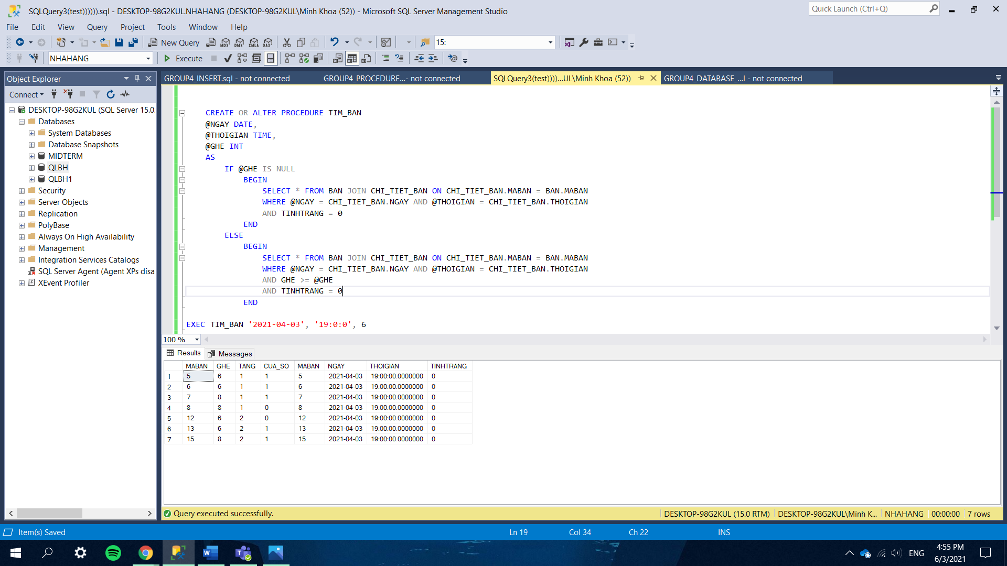

## **8. Triggers**

### *8.1 Calculate the discount and final value of bills.*

The restaurant offers customers a variety of coupons for discount and each time anyone wants to insert a bill into the table, it must go through a trigger. If the customer does not use any coupon, the bill value will stay unchanged but if a customer pays the bill and wants to use a coupon, the system will automatically get the information of that coupon from the table COUPON, compute the discount and the final bill value and then insert into the table HOADON. There are two scenarios when a customer selects a coupon: the discount can be percentage (lower than 1) or fixed monetary value. If it is a percentage coupon, the value after discount is (1 – discount rate) * original value and on the other hand, if the discount is a fixed amount of money, it only needs to subtract that amount from the original value to get the value after discount.

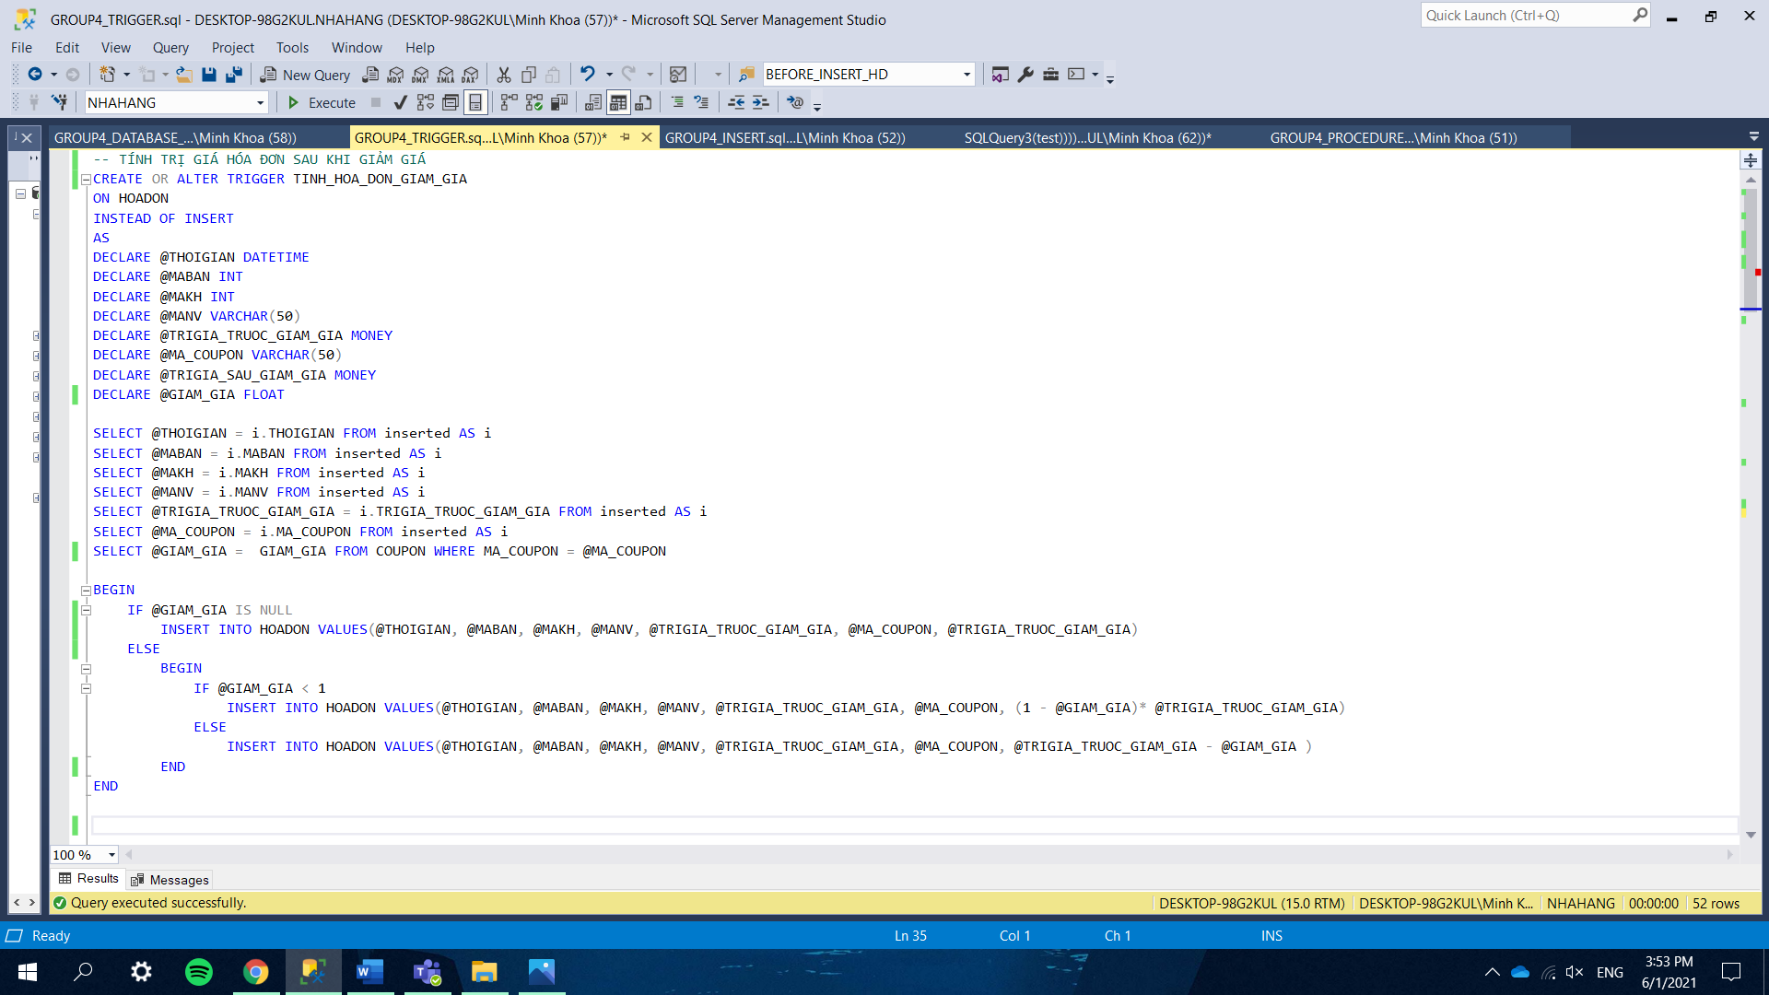

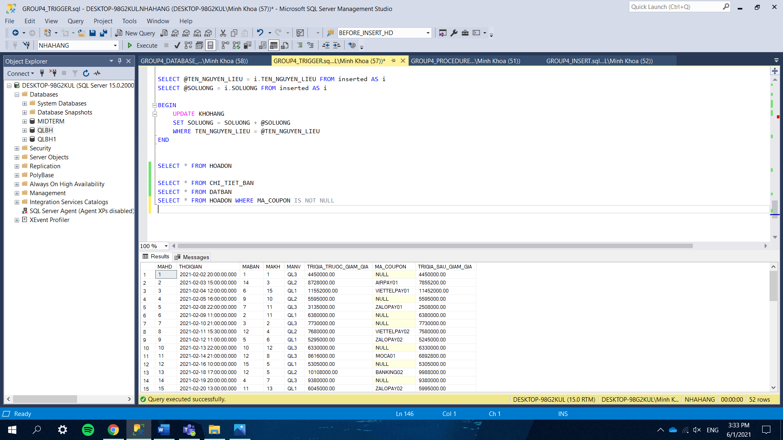

### *8.2 Increase the number of times a customer uses a coupon.*

Every time a bill is inserted into the database, the system will check whether any coupon is used. If the customer does use a coupon, this trigger will find the line of the customer and the coupon code in the table COUPON_DA_SU_DUNG and increase the number of times by 1.

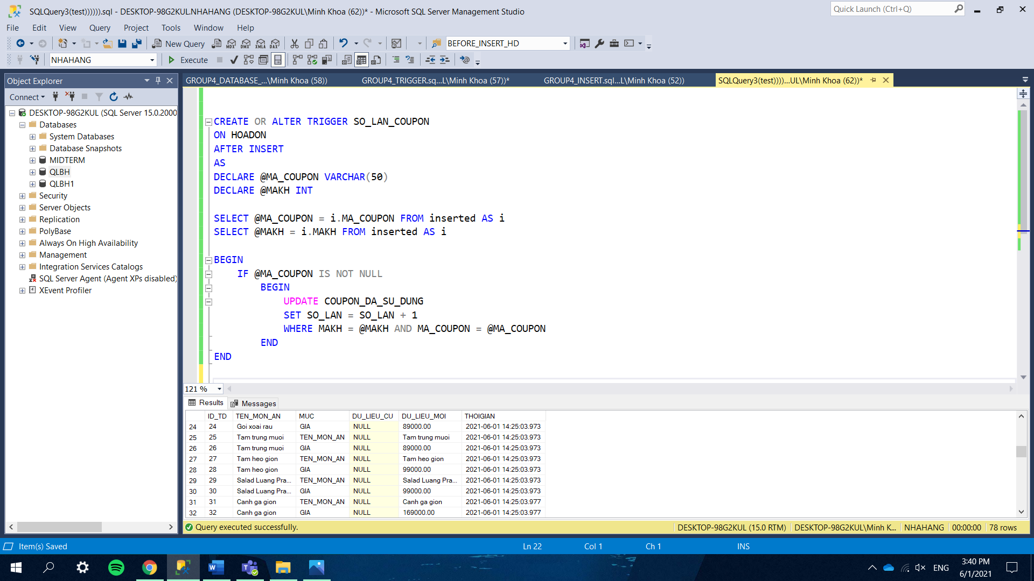

### *8.3 Increase the quantity of ingredients in the warehouse.*

The table KHOHANG stores the ingredient names and their quantity in the warehouse, when an employee makes a purchase of any ingredients and inserts into the table CHI_TIEU, the quantity bought must be added automatically to the current quantity in KHOHANG.

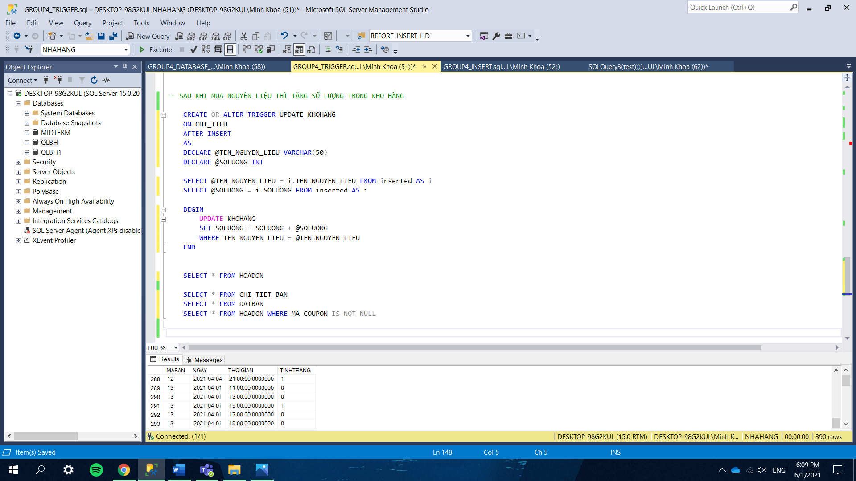

### *8.4 Change the table status.*

When a reservation of a customer is recorded, this trigger will get the table code, date and time and find the line in the table CHI_TIET_BAN and change the status from available (0) to booked (1).

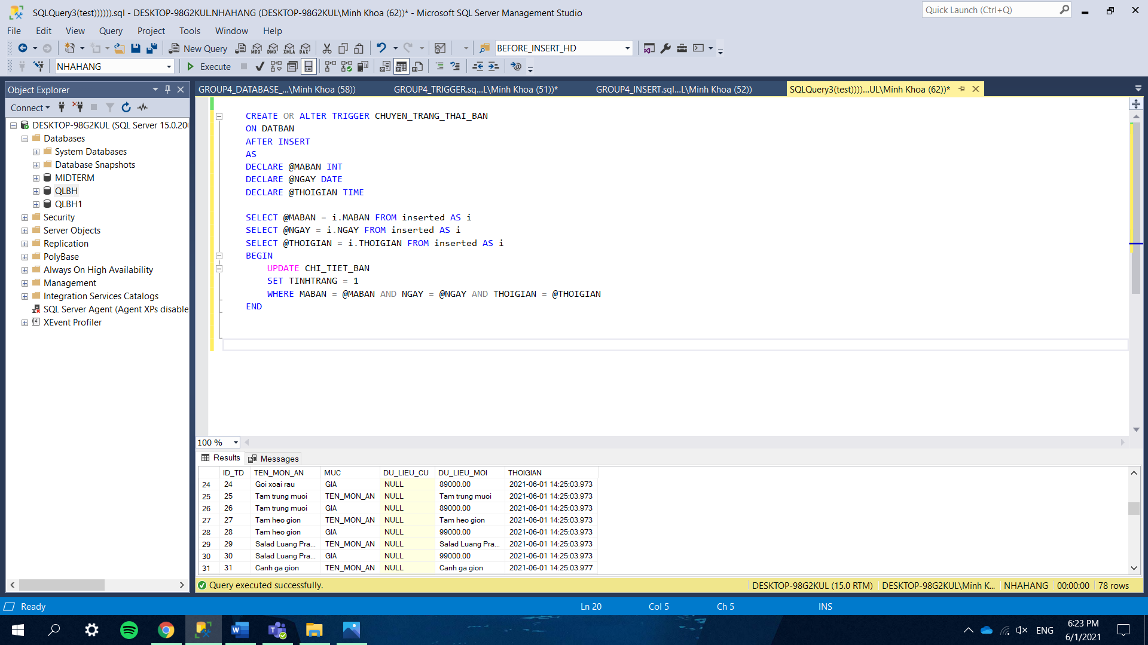

### *8.5 Delete food from the menu.*

When the restaurant decides to remove an item from the table MON_AN, the action should be recorded and saved to another table (THAY_DOI)

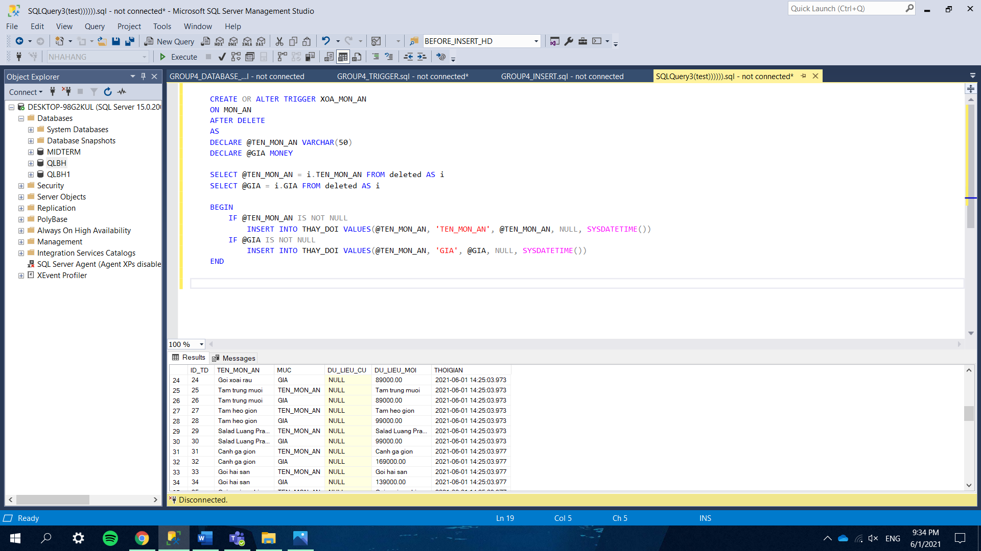

### *8.6 Insert or update foods.*

Each time the restaurant introduces a new dish to customers or when any dish is modified, the changes should be noted and saved to the table THAY_DOI for future use such as to see how many times this dish has been changed and in what field, how often do the changes take place and are the new values significantly different from the old ones…..

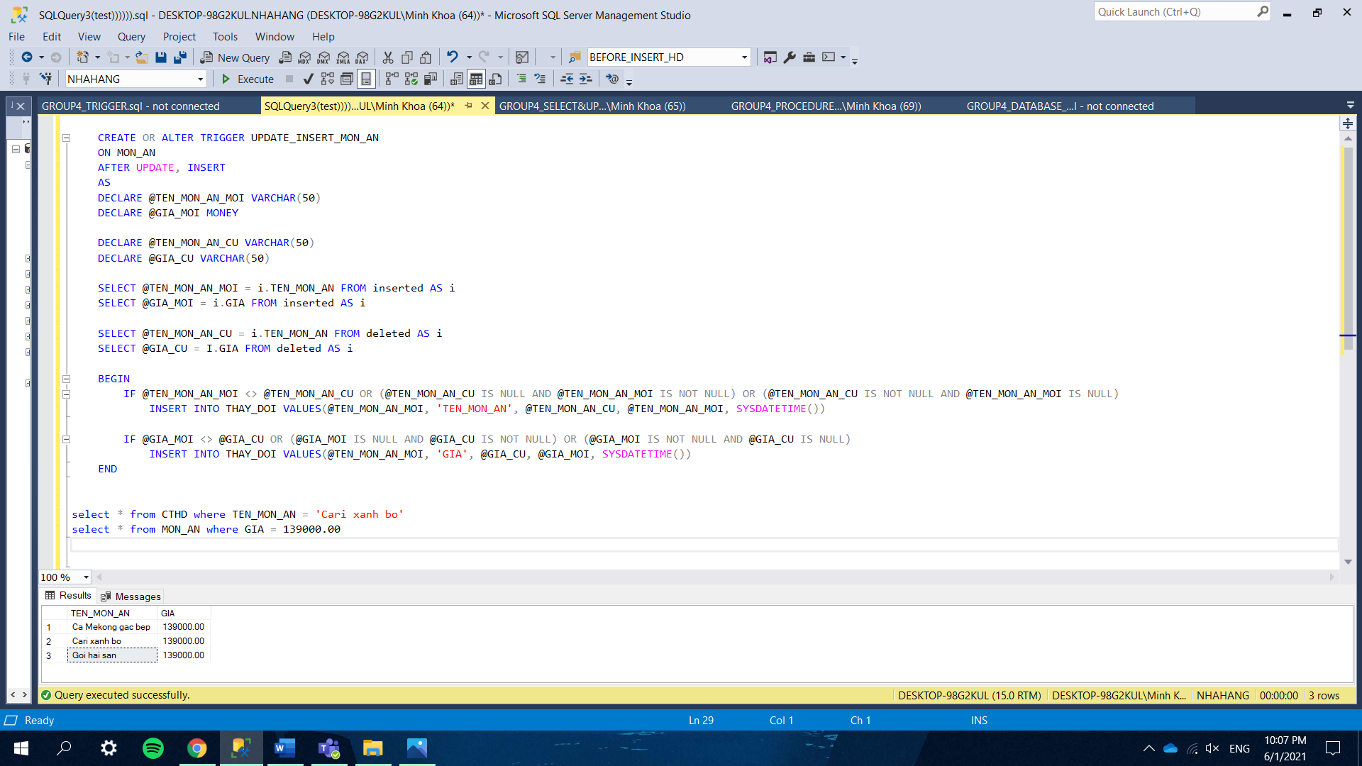

III. CONCLUSION.

- It is feasible to provide a clear diagram, model, and method of operating the restaurant using the SQL software. Following that, we learned more about the company's database. Employee salaries, restaurant income, and other issues are investigated in the quickest and most efficient manner possible. As a result, we will have a greater understanding of how small and medium-sized restaurants function.

- Each team member contributes 100% of their efforts to the project. So each person will get 25% out of 100%.

-------------------------------------------------THE END--------------------------------------------

THE REPORT OF GROUP 4 COMES TO AN END HERE. THANK YOU FOR TAKING THE TIME TO READ THIS ARTICLE !